

**Dynamics 365 - Demand Management and Inventory Shortage**

**Revision 1**

**Revision History**

|  |  |  |  |  |
| --- | --- | --- | --- | --- |
| **Date** | **Revision** | **Description** | **Signature / Date** | |
| 30/03/2022 | 1 | Initial draft of user manual: Demand Management and Inventory Shortage | Prepared | Salman Tahir |
|  |  | Verified |  |
|  |  | Approved |  |
| 27/10/2022 | 2 | User Manual: Demand Management and Inventory Shortage | Prepared | Waseem Abbas |
|  |  | Verified |  |
|  |  | Approved |  |
|  |  |  | Prepared |  |
|  |  |  |  |
|  |  |  |  |
|  |  |  |  |  |
|  |  |  |  |
|  |  |  |  |

**Table of Contents**

1 About User Manual 7

1.1 Dynamics 365 Finance and Operations 7

2 Production Order 8

2.1 Production Order List 9

2.2 New Production Order 9

2.3 New Production Order Data 10

2.4 Calculate Production Order 10

2.5 Production Ordering Batch Job Monitoring 14

2.5.1 Batch Job List 14

2.5.2 Selected Batch Job 15

2.6 Reset Production Order 15

3 Consolidate Report 17

4 Inventory Shortage Report 18

5 Explosion View 20

5.1 Overview 20

5.2 Gantt Chart 20

5.3 Critical on-hand Inventory 21

5.4 Action 21

5.4.1 Filter and Open Sub-Assembly 22

6 Remove Existing Planned Orders 23

6.1 Explosion View 23

6.2 Open Planned Orders 24

6.3 Select and Remove Planned Orders 24

7 Production Order Calculations (Optional) 25

7.1 Recalculate Inventory Shortage Report 25

7.2 Reset Inventory Shortage Report 26

7.3 Manual Calculation of the production order 29

7.3.1 Estimation of the production order 29

7.3.2 Scheduling of the Production Order 30

7.3.3 Release of the production order 32

7.3.4 Reset Status 34

7.3.5 End of the production order 35

8 Personalization 36

8.1 Add columns 36

8.1.1 Select Column Header 36

8.1.2 Select Required Columns and Update 36

8.2 Hide User Control 38

8.2.1 Select Control to Hide 38

8.2.2 Apply Hide Control 38

8.3 Rename Label 38

8.3.1 Personalize Label 38

8.3.2 Update Label Text 39

8.4 Favorites 39

8.4.1 Add to Favorites 39

8.4.2 Remove from Favorites 40

List of Figures

Figure 1 Dynamics 365 main Dashboard 7

Figure 2 Click on the Expand Navigation Pane' 8

Figure 3 Expand the 'Modules' option 8

Figure 4 Select the Production control' and click 'All production orders' 9

Figure 5 Production Order Workspace 9

Figure 6. Select New Production Order' available on top 10

Figure 7 Add details to create production Order 10

Figure 8 Calculate Production Order 11

Figure 9 Confirm and press OK to Estimate Production Order 11

Figure 10 Operation Scheduling to Calculate Production Scheduling 12

Figure 11 Pop up Calculate Inventory Shortage Report 12

Figure 12 Fill Data and Press OK to Recalculate 13

Figure 13 Success Message of Calculate Batch Job 13

Figure 14 Wait Message If the already job in Queue 14

Figure 15 Production Ordering Batch Job Monitoring 14

Figure 16 Monitoring Batch Job 15

Figure 17 Selected Batch Job 15

Figure 18 Reset Production Order 16

Figure 19 Selection of Reset Status 16

Figure 20 Success Message of Reset Production Order 17

Figure 21 Error While Reset the Status of the Production Order 17

Figure 22 Consolidate Report 18

Figure 23 Consolidate Report of Specific Production Order 18

Figure 24 Inventory Shortage Report 19

Figure 25 Open Inventory Shortage Report of the production Order 19

Figure 26 Inventory Shortage Report of the Specific production Order 19

Figure 27 Select the 'View' tab and click on the 'Explosion' Option 20

Figure 28 To view BOM’s associated with production order, select the ‘Overview’ Option 20

Figure 29 Shows the graphical representation of parts lead time 21

Figure 30 Show on-hand and need to order inventory details 21

Figure 31 Shows how inventory shortage will be managed 22

Figure 32 To find specific item number 22

Figure 33 Select the 'View' tab and click on 'Explosion' 23

Figure 34 Select the 'Planned Orders' available on top 24

Figure 35 Check mark those planned orders you want to delete 24

Figure 36 Recalculate Inventory Shortage Report 25

Figure 37 Fill Data and Press OK to Recalculate 25

Figure 38 Success Message of Recalculating Inventory Shortage Report 26

Figure 39 Wait Message If the already job in Queue 26

Figure 40 Reset Inventory Shortage Report 27

Figure 41 Success Message of Reset Inventory Shortage Report 27

Figure 42 Wait Message If the already job in Queue 28

Figure 43 Estimation of the Production Order 29

Figure 44 Estimate the values 30

Figure 45 Scheduling of the Production Order 31

Figure 46 Navigate to 'Schedule' tab and select Schedule Operations 31

Figure 47 Add parameters in Operations scheduling 32

Figure 48 Production Scheduling Completed 32

Figure 49 Release of the Production Order 33

Figure 50 Confirm Data and Press OK 33

Figure 51 Reset Status 34

Figure 52 Select Status to Reset Status 34

Figure 53 End of the production Order 35

Figure 54 Confirm Data and Press OK 35

Figure 55 Production Order Ended 36

Figure 56 Right click on column header and select 'Insert columns' 36

Figure 57 Choose the columns you want to add 37

Figure 58 Select the field you want to hide 38

Figure 59 Tick the check box of Hide 38

Figure 60 Select the Field You Want to Rename 39

Figure 61 Enter the new field name 39

Figure 62 Add to Favorites 40

Figure 63 Remove from Favorites 40

# About User Manual

This document describes the step-by-step guide for creation of a production order (PRO) of a product. These production orders (PROs) are typically created by orderer in a legal entity (legal organization). The production order includes information about the items or products that will be produced, the size of production, and the planned delivery date. It also comprises information about which resources to use and which procedure to follow to produce the items. A production order passes through different stages of the life cycle.

In this manual, the procedure of creating production order and information regarding inventory will be briefed out.

## Dynamics 365 Finance and Operations

To access and to perform different operations, the login credential (Login ID, Password), along with, the web link of Microsoft Dynamics 365 for Finance and Operations are provided by the legal entity (organization).

After logging in, the user will see the main dashboard, which includes the grid of individual Workspaces like Purchase Order Preparation, Master Planning, Cost Analysis etc. which are represented in the **Figure 1**.

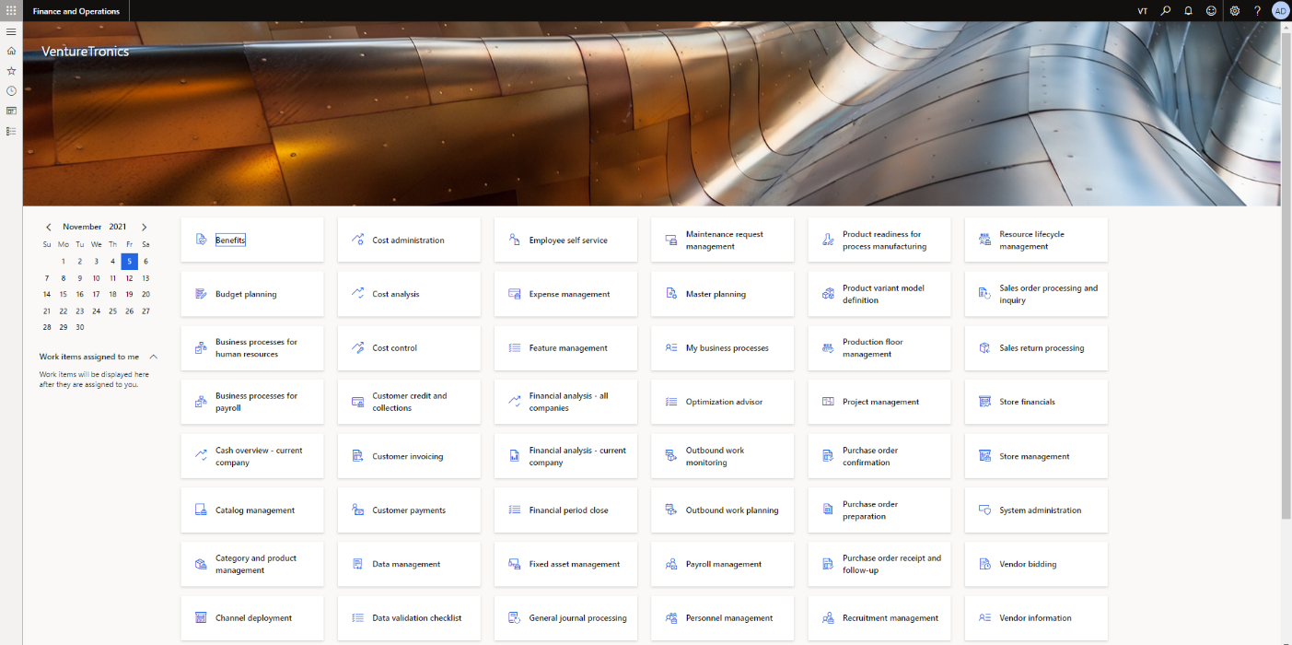

Figure 1 Dynamics 365 main Dashboard

# Production Order

The way to access the production order (PRO) module, especially, for creating a new Production and for getting the summarized and detailed information of all PROs in the Microsoft Dynamics 365 for Finance and Operations application.   
Navigate to the top left corner of main dashboard and select ‘Expand Navigation Pane’. Upon clicking, the sliding panel composing of different options will appear.

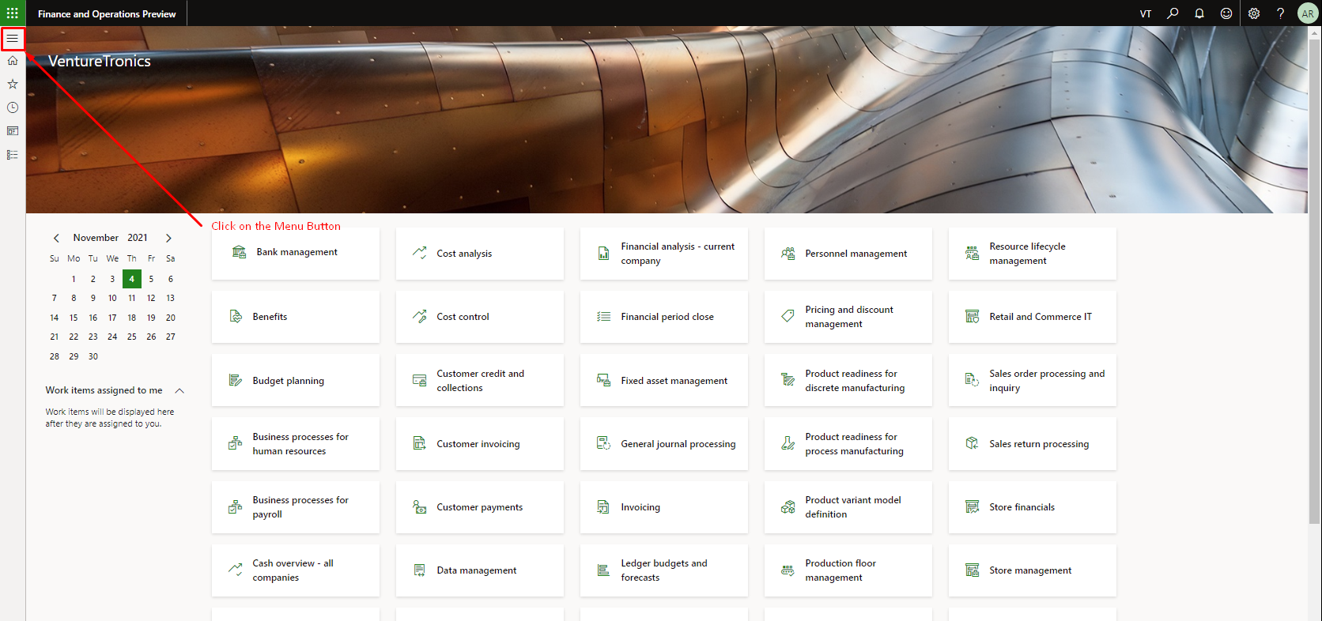

Figure 2 Click on the Expand Navigation Pane'

Different options will appear when you click on the modules.

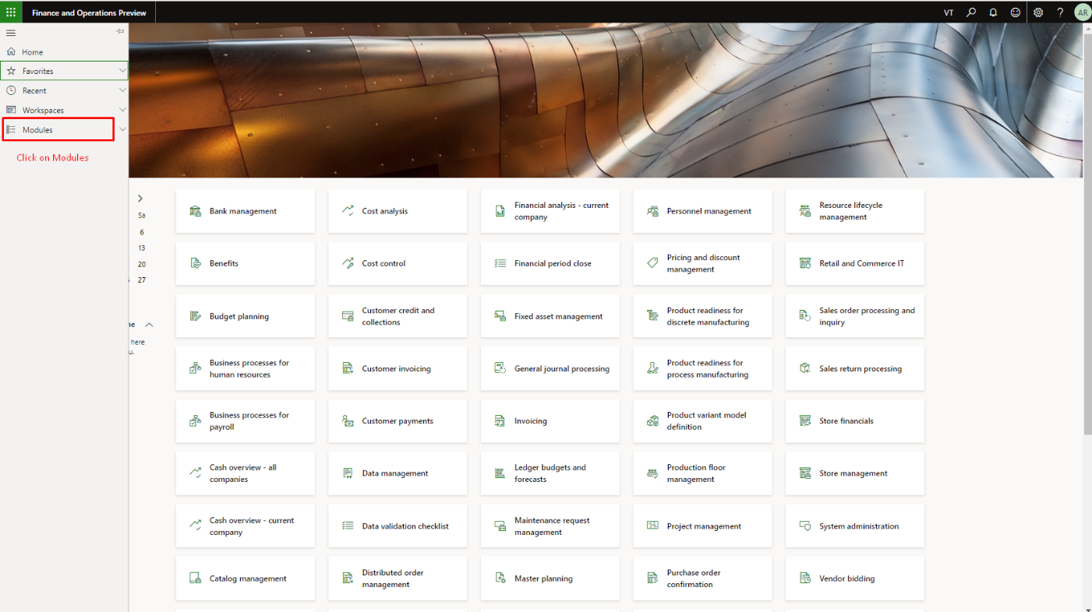

Figure 3 Expand the 'Modules' option

Scroll down and select production control. After selecting production control option, the sub-options relating to your selection will appear. Expand the Production order and choose ‘All production orders. By clicking, production order page will appear.

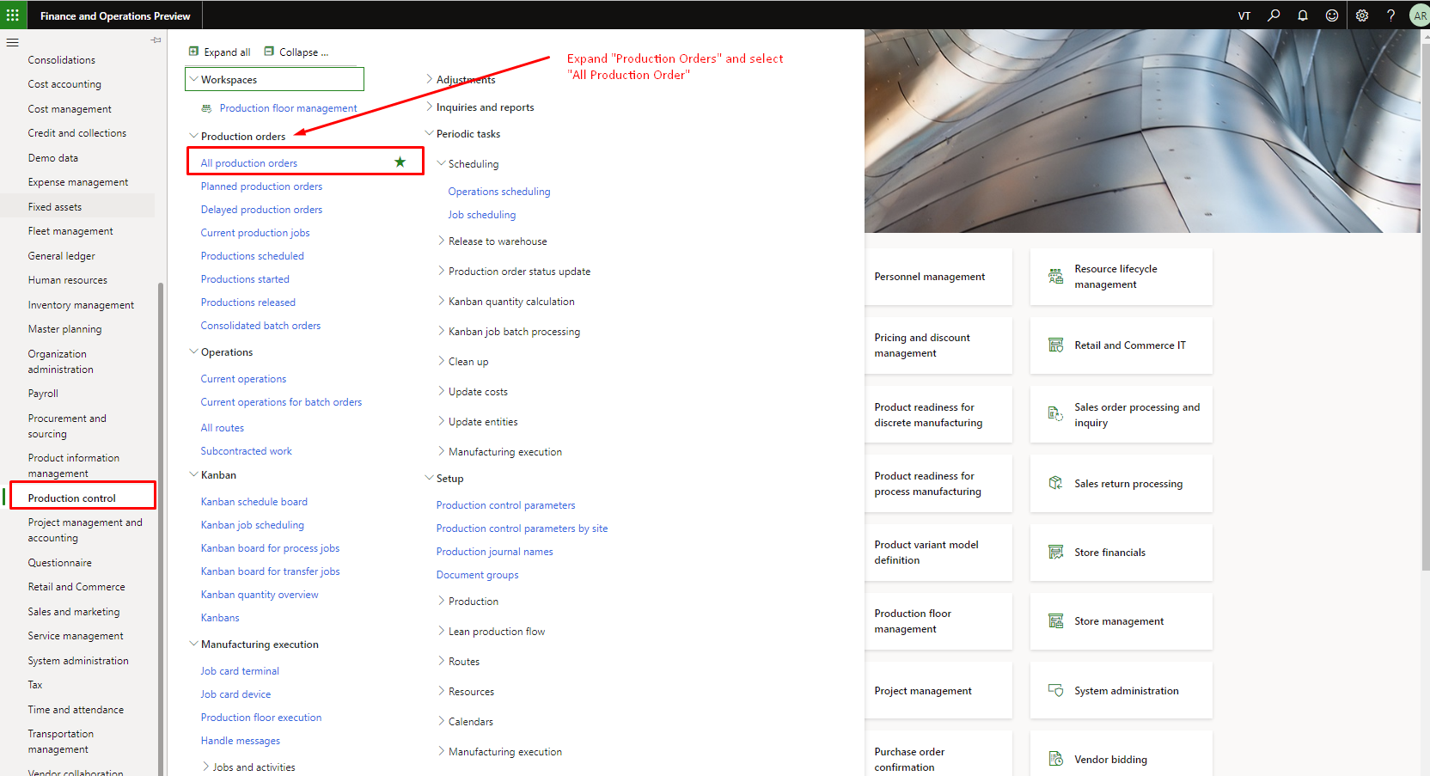

Figure 4 Select the Production control' and click 'All production orders'

## ****Production Order List****

The production of items, goes through a process known as life cycle of production. In this life cycle, specific steps are needed to follow for the production criteria. The life cycle starts with the production order creation. The life cycle terminates with a finished or completely manufactured item that is ready for customer delivery or ready for another phase of production. A single production order is composed of number of assemblies. In production order life cycle, there is a possibility of inventory shortage which can cause delay in production. The information regarding inventory shortage will also be discussed in this manual.

Here is guide for creation of a new production order (PO), which is given below:

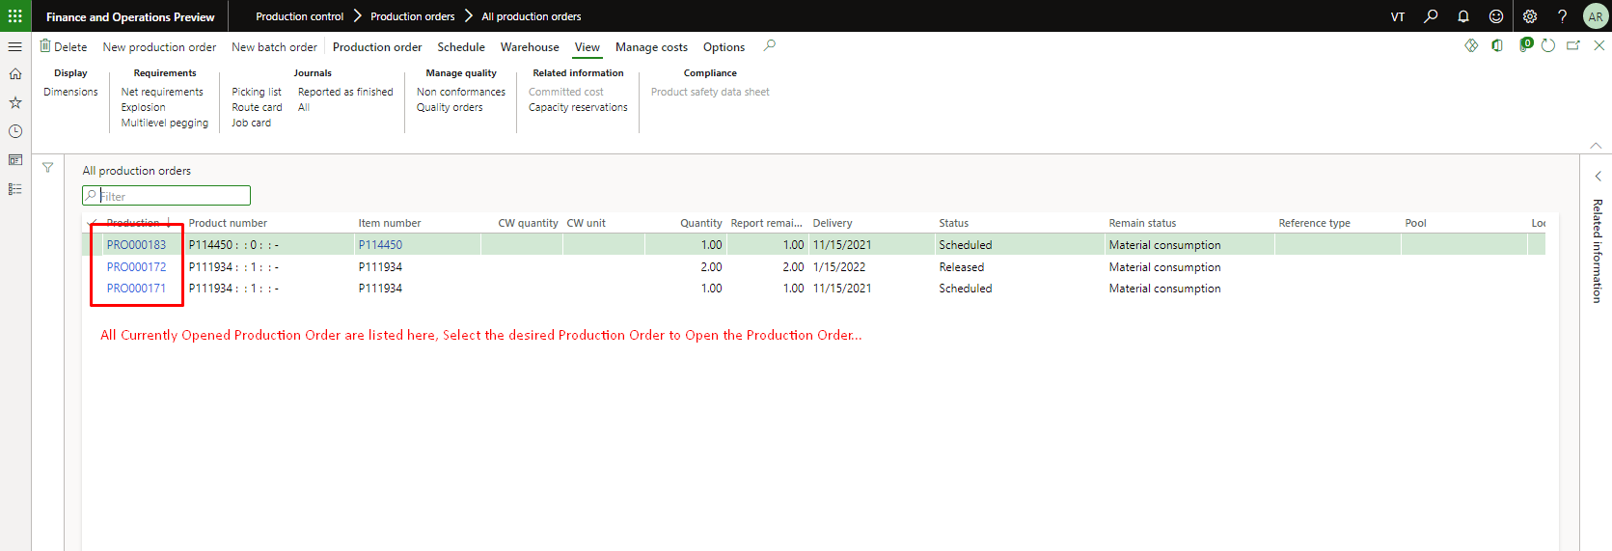

Figure 5 Production Order Workspace

## New Production Order

For creating new production order, click on the production order button available on the top of toolbar. Upon clicking, a window containing different fields will appear from the right.

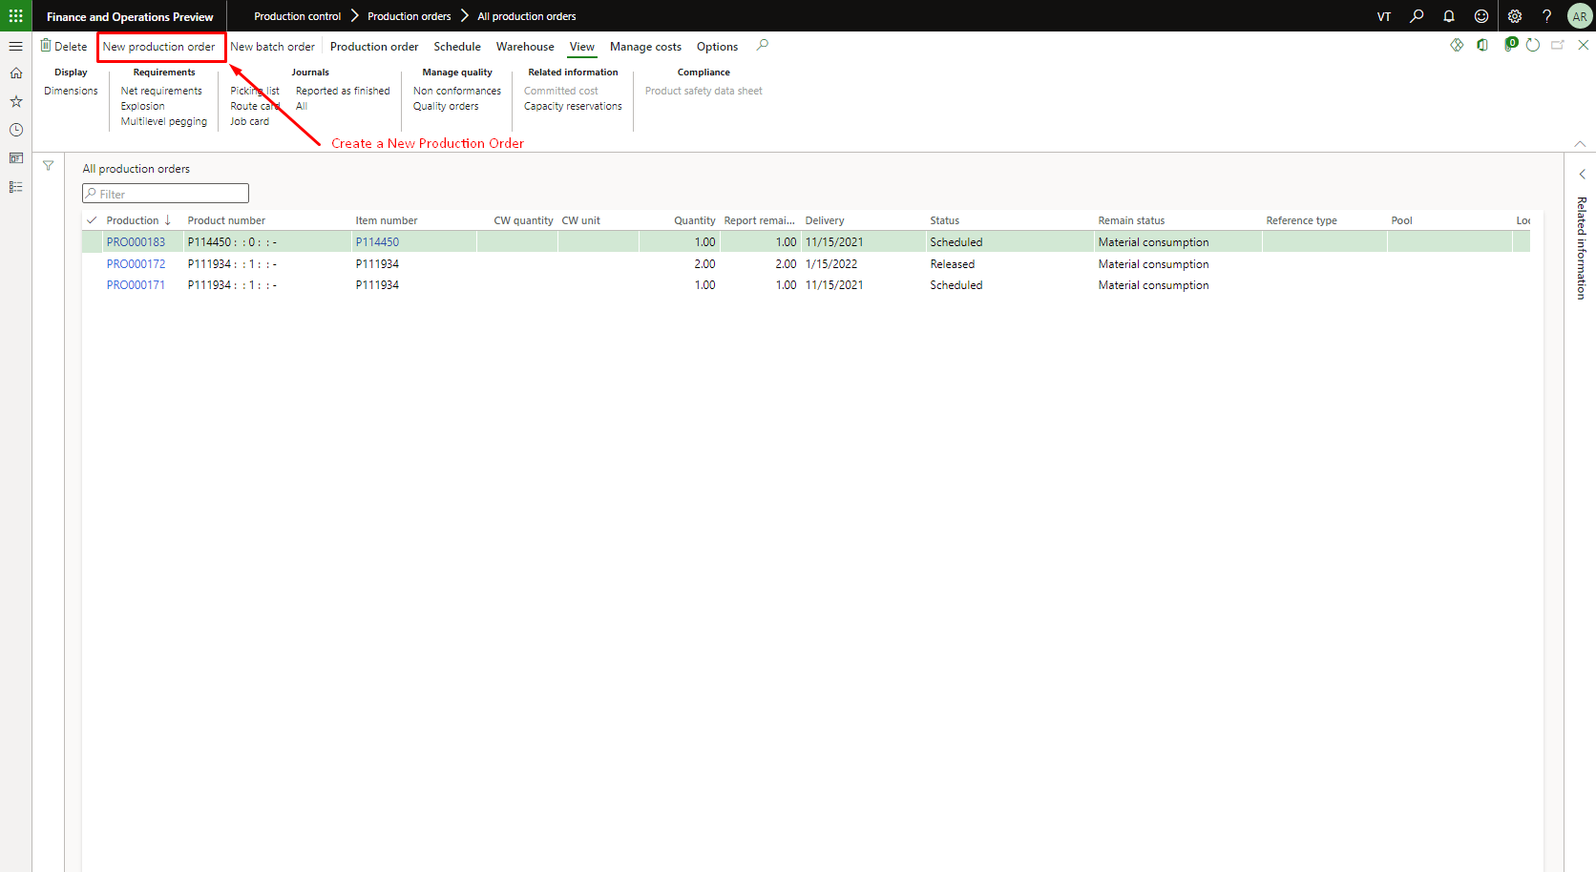

Figure 6. Select New Production Order' available on top

## New Production Order Data

Enter the details in the fields for creating production order. Some fields will automatically be filled like Production ID etc. **This process is already highlighted in the Figure 7.**

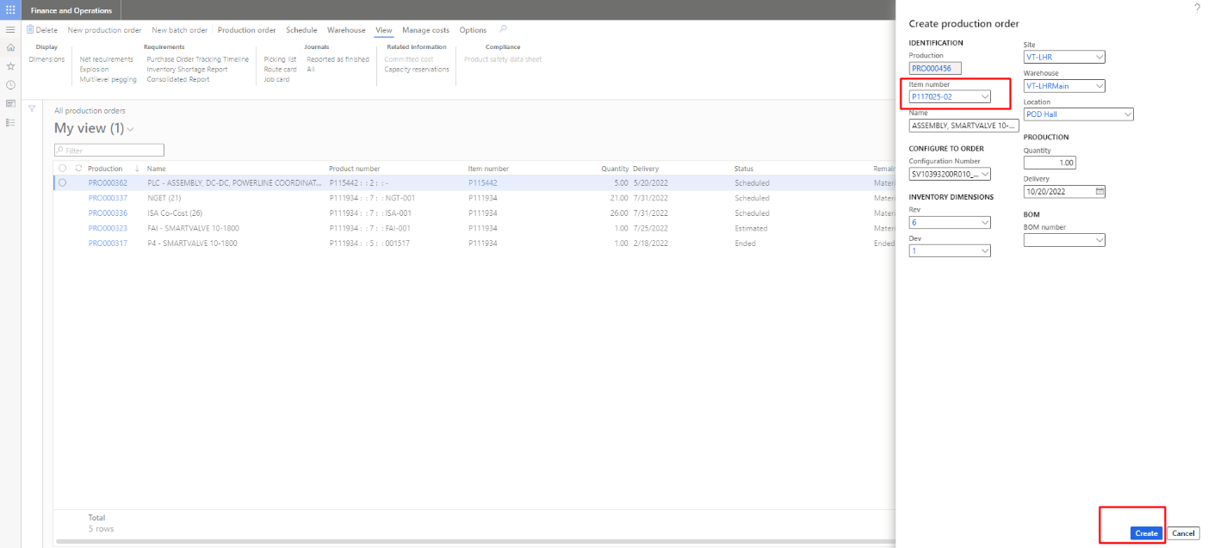

Figure 7 Add details to create production Order

## Calculate Production Order

**If you want to calculate the Batch Job of the production order, click on the “Calculate Purchase Order” tab (from purchase order). The user will be able to see the detail pop to calculate the shortage batch job. The need to fill the data as per requirement to calculate job then click on “OK” to submit the calculation. As the user press the “Yes” then user will be able to see the detail pop to fill the data as per requirement to calculate job then click on “OK” to submit the calculation which is also highlighted in the Figure 9 and 10. User then will move to operation scheduling to select the date and limitations to calculate the batch job which is also highlighted in the Figure 11. If another job is in the Queue then user will receive the message to wait until its completed other user will receive the success message. which is also highlighted in the Figure 12 and 13. If the user receives the success message then can check its operation in batch job to check its status. Batch job have different status like waiting, error and ending.**

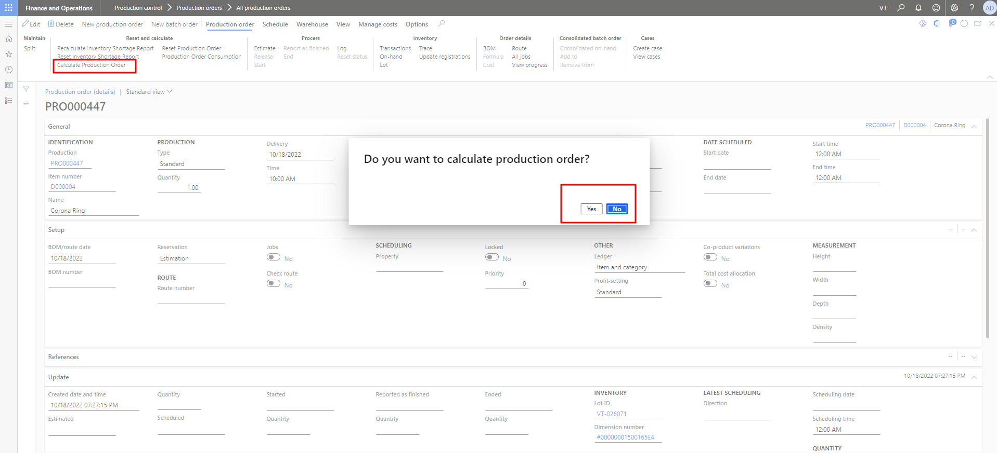

Figure 8 Calculate Production Order

The user will estimate the production order and it can be calculated after created the production order.

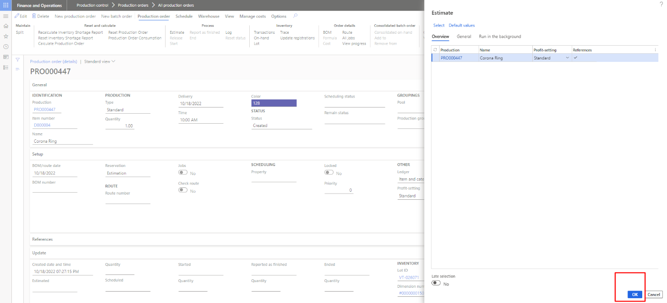

Figure 9 Confirm and press OK to Estimate Production Order

The user will perform the operation scheduling of the production order by filling the scheduling parameters.

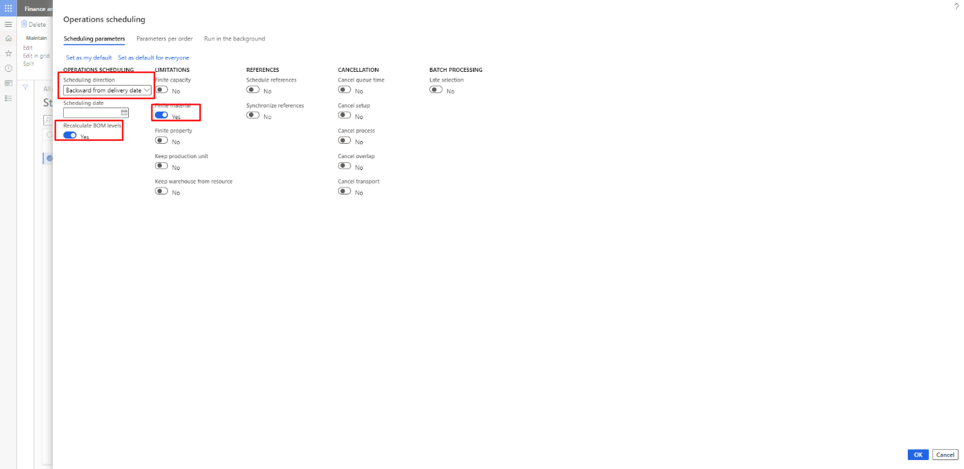

Figure 10 Operation Scheduling to Calculate Production Scheduling

The user will receive the popup to calculate the inventory shortage report of the production order.

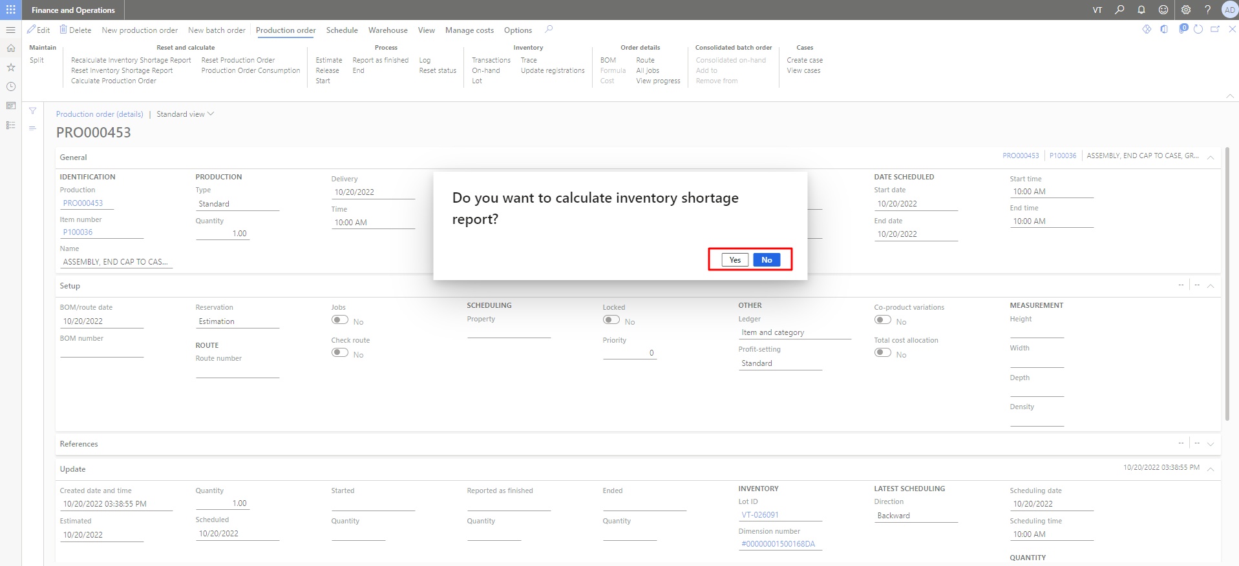

Figure 11 Pop up Calculate Inventory Shortage Report

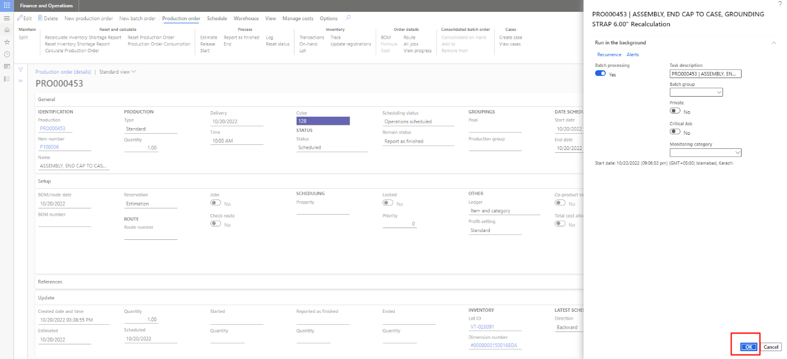

Figure 12 Fill Data and Press OK to Recalculate

The user will receive the access the success message (Job is added in the batch Queue) after performing all the calculations to calculate the production order. It is the automate process to calculate the all the calculation of the production order.

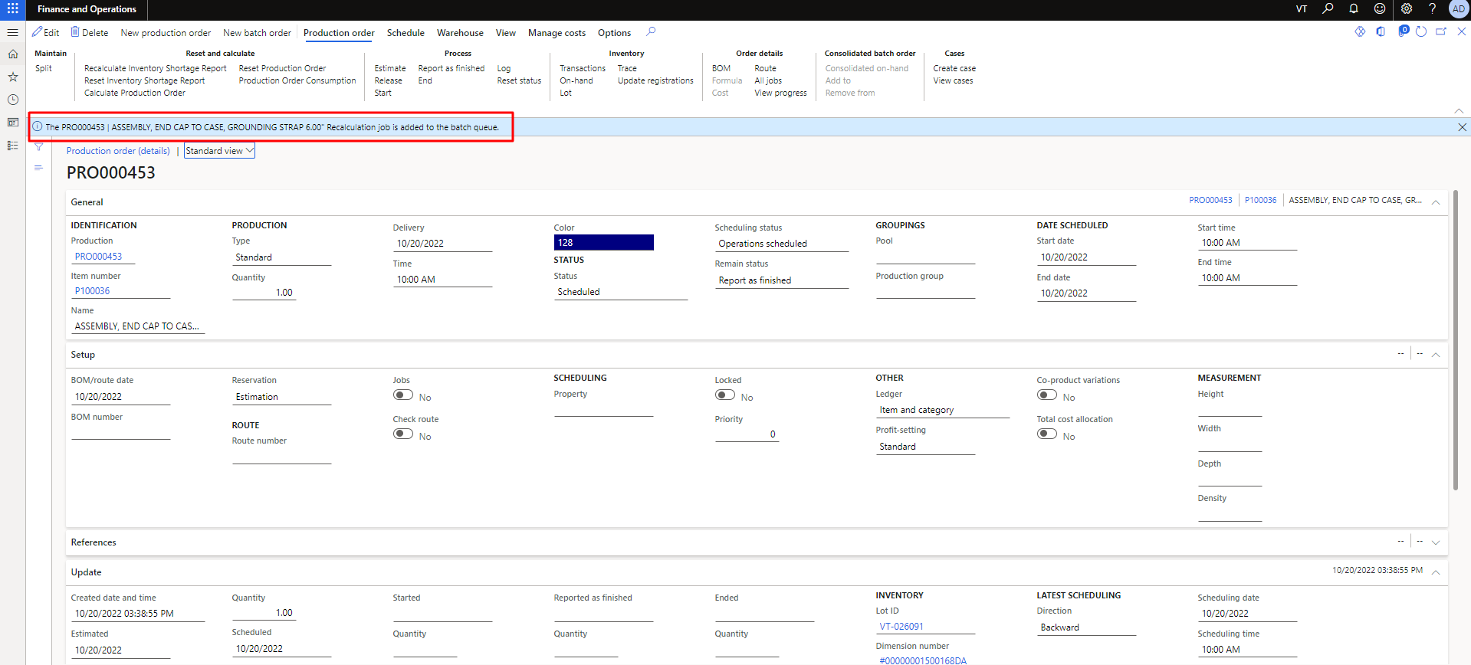

Figure 13 Success Message of Calculate Batch Job

The user will receive the access the Failure message (Please wait for the process to end), If the any of the job is already in the queue.

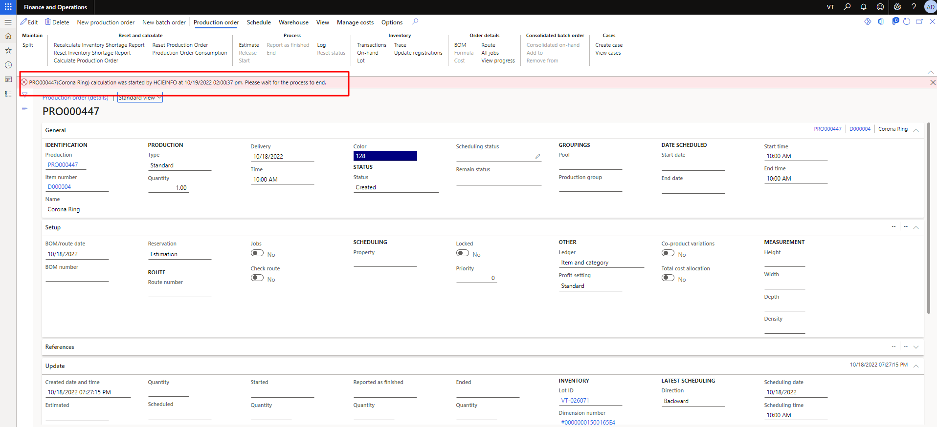

Figure 14 Wait Message If the already job in Queue

## Production Ordering Batch Job Monitoring

The user can get Batch job by clicking on module then production to click on all system administrations. The process can understand by seeing the below **Figure 16.** As the user click on the batch job then will be able to review the list of batch jobs with their status which is shown in the **Figure 17**. The user only can perform the reset or calculation only if the status of job is ended. The user can filter their specific batch job by searching its PO number and compare its ID. Batch job have different status like Waiting, Error and Ended.

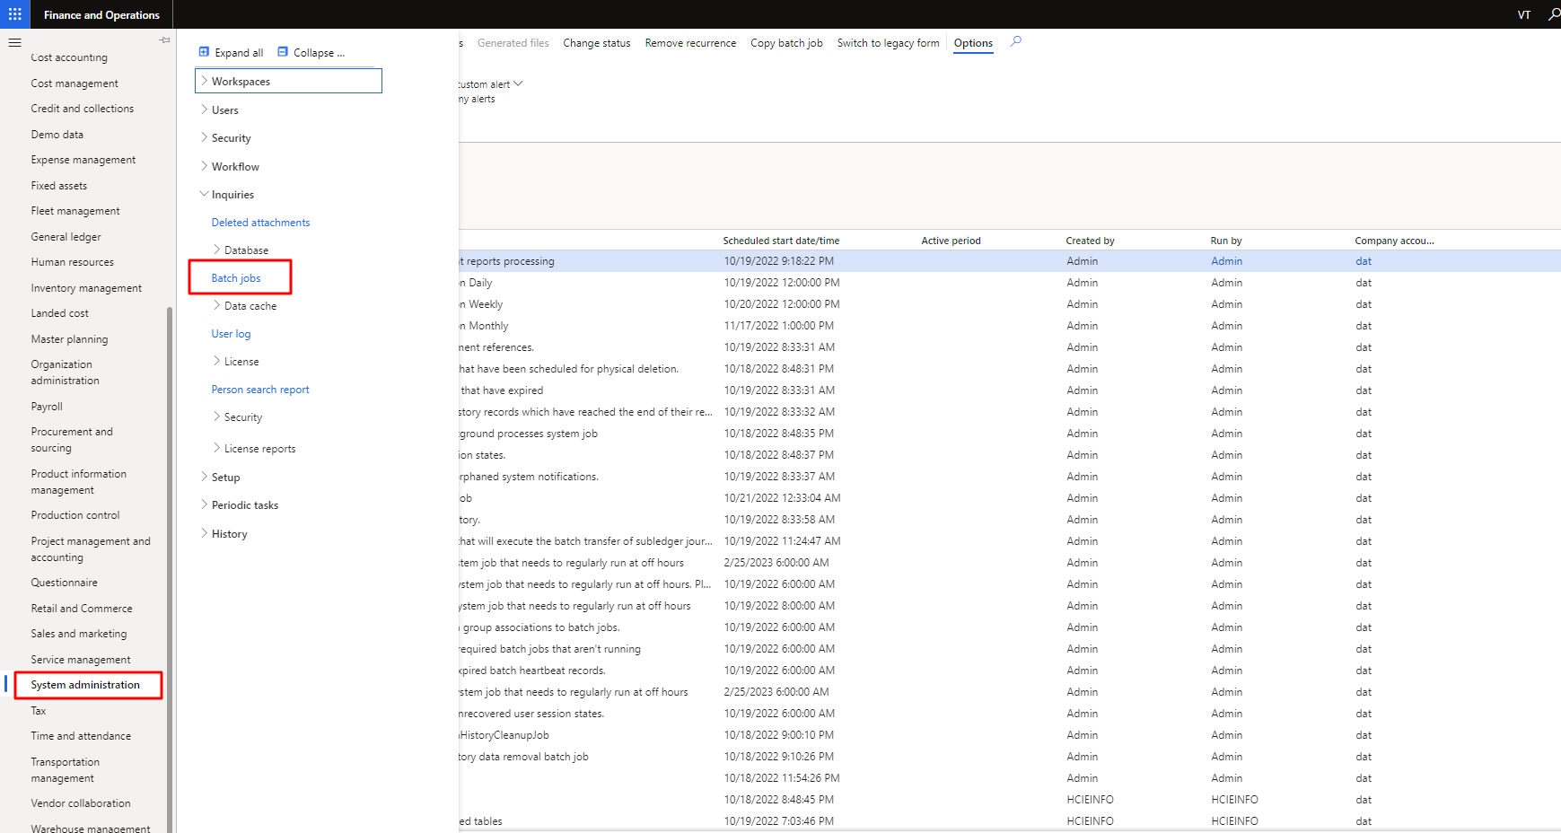

Figure 15 Production Ordering Batch Job Monitoring

### Batch Job List

The user needs to clicks on the batch job to review the list of batch jobs with their status which is shown in the **Figure 16**. Batch job have different status like Waiting, Error and Ended. The user only can perform the reset or calculation only if the status of job is ended. The user can filter their specific batch job by searching its PO number and compare its ID. Batch job have different status like Waiting, Error and Ended.

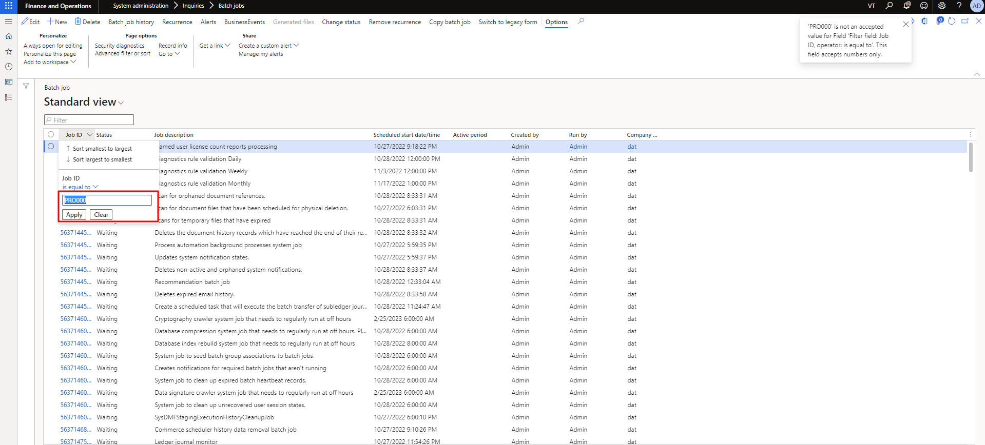

Figure 16 Monitoring Batch Job

### Selected Batch Job

The user can filter to find their specific job to check its status.

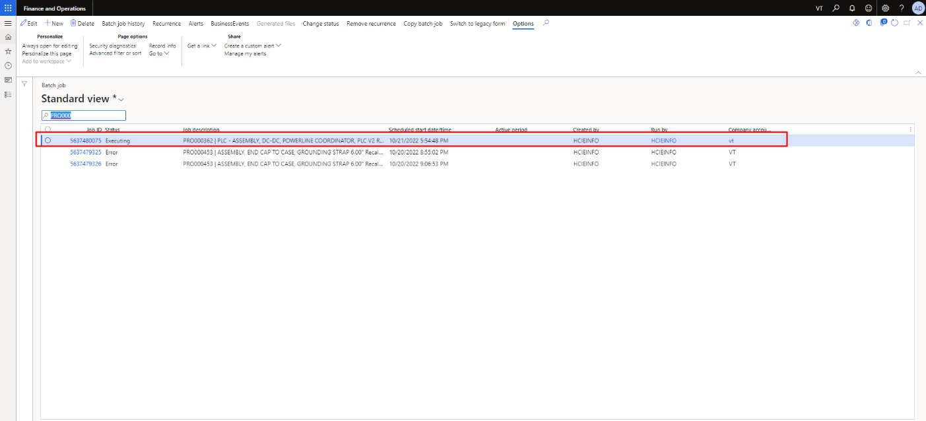

Figure 17 Selected Batch Job

## Reset Production Order

**If you want to Reset Production order of the batch job, click on the “Reset Inventory Shortage Report” tab (from purchase order). The user will be able to see the detail pop to calculate the shortage batch job. The need to fill the data as per requirement to calculate job then click on “OK” to submit the calculation. As the user press the “Yes” then user will be able to see the detail pop to fill the data as per requirement to calculate job then click on “OK” to submit the calculation which is also highlighted in the Figure 19 and 20. If desired status is as per order then user will receive the message to reset cannot be forwarded otherwise user will receive the success message. which is also highlighted in the Figure 21 and 22.**

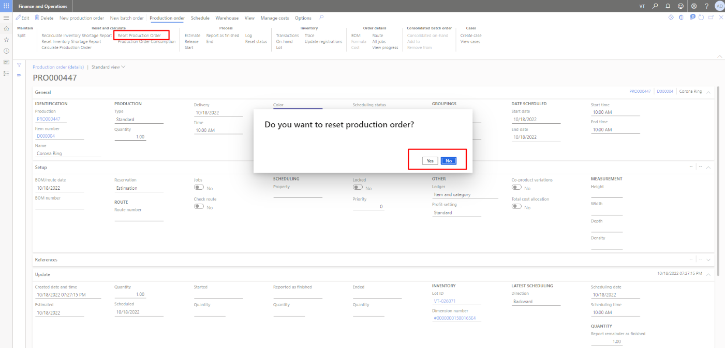

Figure 18 Reset Production Order

The user can reset the status of the production order by selecting its desired status. The user can only reset in descending order Scheduling, Estimate etc.

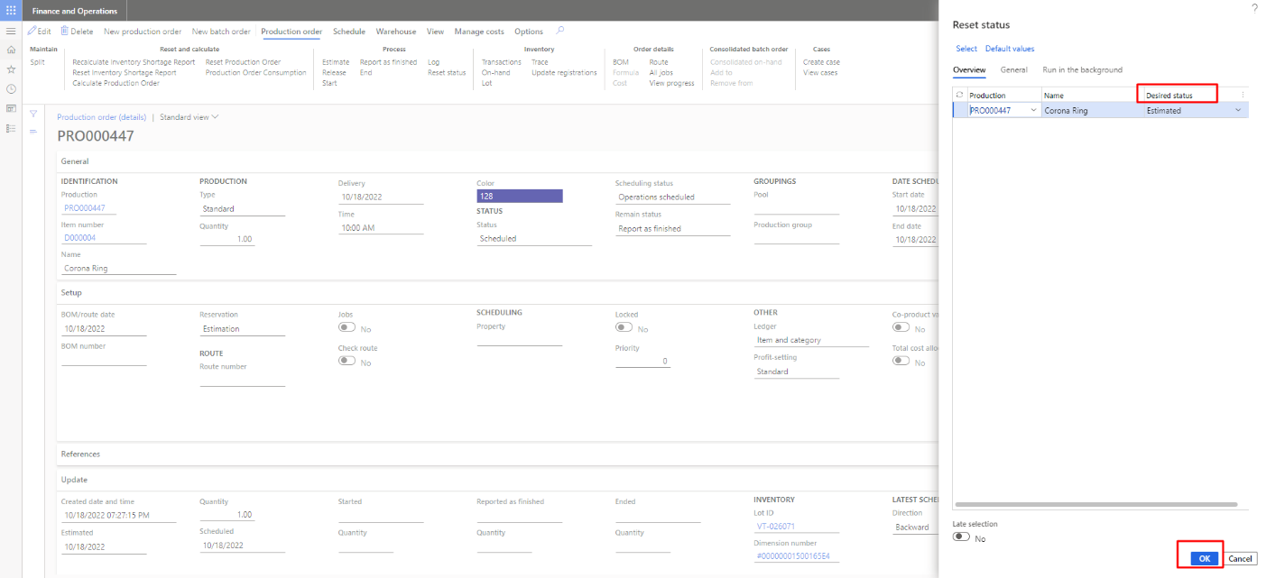

Figure 19 Selection of Reset Status

The user can reset the status of the production order by selecting its desired status. The user can see in the above Figure that production order has the Estimated status of the production order. Now, In the below Figure can see that status of the production order is converted from Estimated to Created.

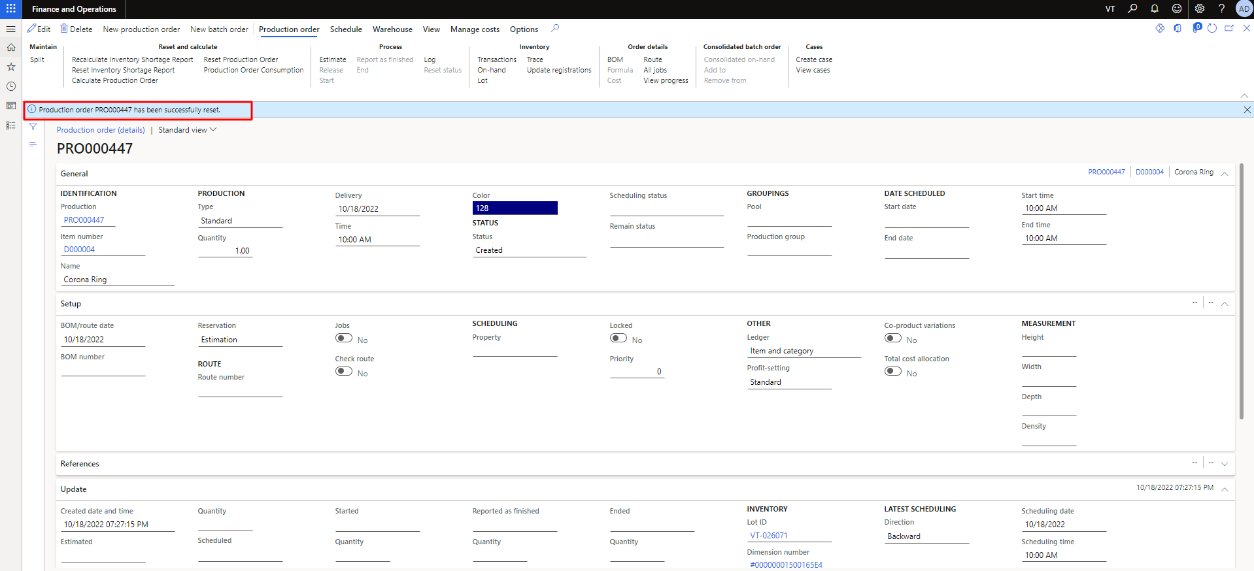

Figure 20 Success Message of Reset Production Order

The user can reset the production order with an order, In the below Figure user can see that production order has the first status of the production order. User can’t forward to another status to it.

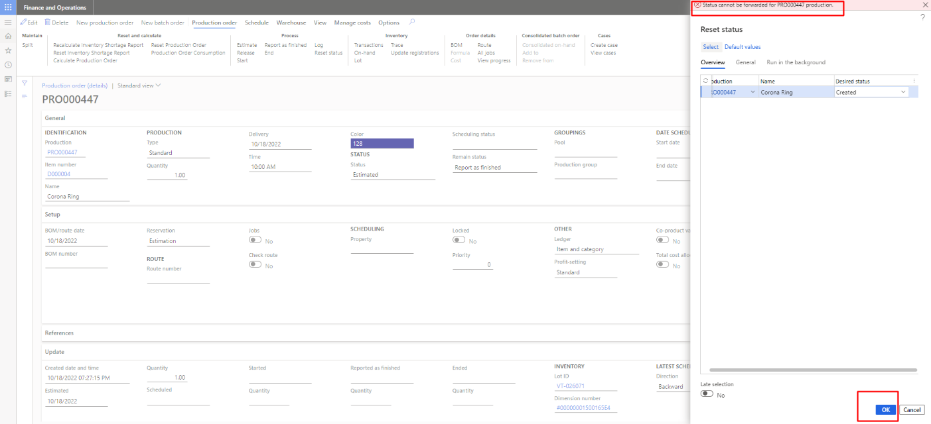

Figure 21 Error While Reset the Status of the Production Order

# Consolidate Report

The user needs to open the all production orders to access the Consolidate Report. The user needs to click on consolidate report from View Tab. Consolidate report show us what is require to make any item and what we have in our stack to make. The user can see the consolidate report of the production order in the **Figure** **23**. As the you can see in the **Figure 23** production order has the part numbers. User can see the On-Hand Items, Need to Orders, Delays Days, Available Inventory and Type. every part number have unique these properties. The user can also view each part number by filtering these properties like user can see the Make or Buy or Assembly by implementing the filter.

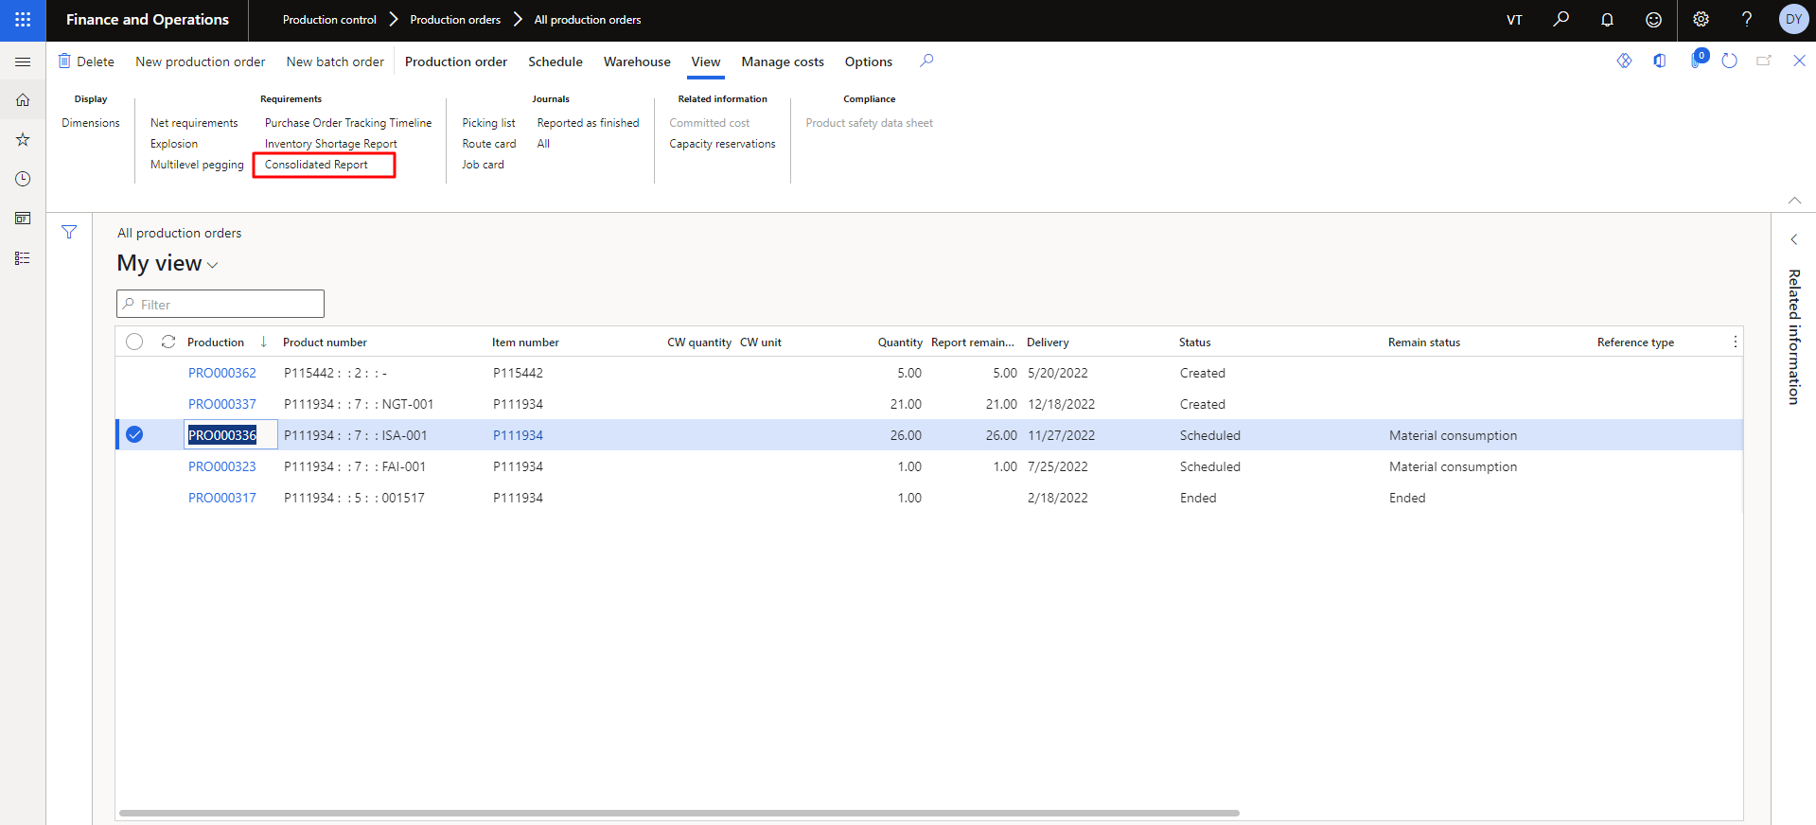

Figure 22 Consolidate Report

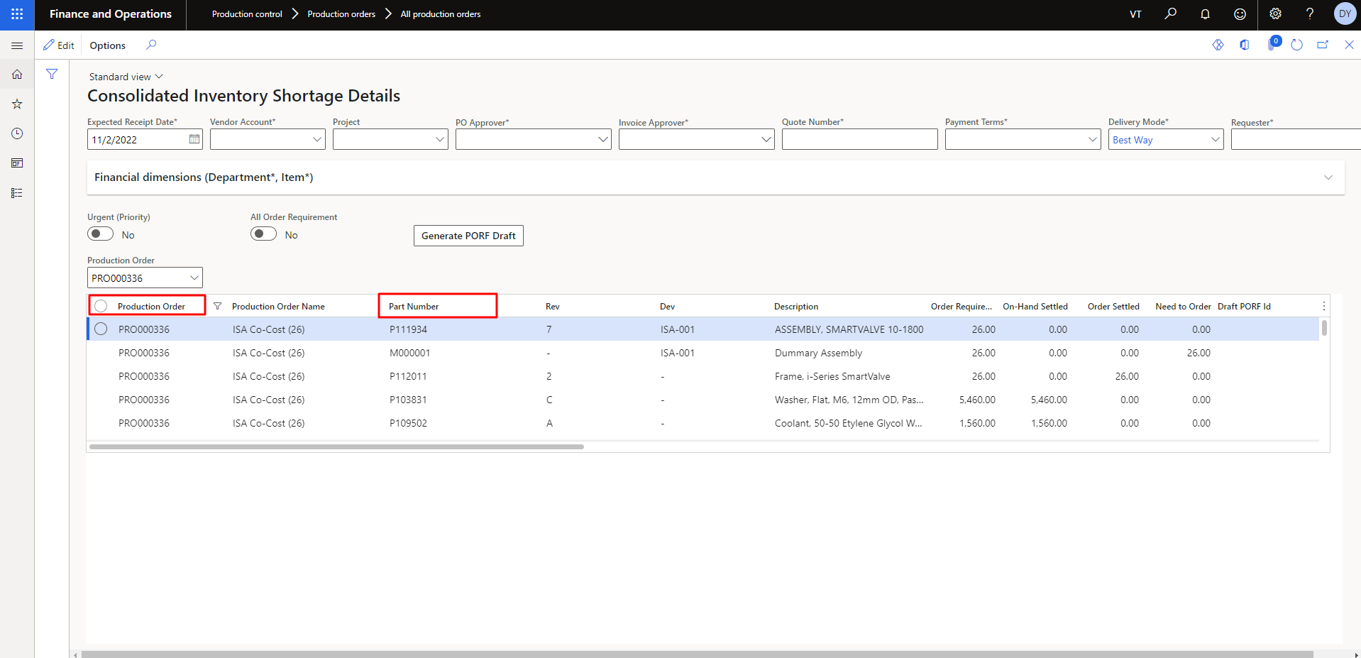

Figure 23 Consolidate Report of Specific Production Order

# Inventory Shortage Report

The user needs to open the all production orders to access the Inventory Shortage Report. The user needs to click on Inventory Shortage report from View Tab. The user can see the Inventory Shortage Report of the production order in the **Figure** **26**. Production Order has the parent number and part number. It’s a one to many relations between parent and part number. A parent number can have the multiple part numbers. As the you can see in the **Figure 26** production order has the part numbers. User can see the On-Hand Items, Need to Orders, Delays Days, Available Inventory and Type. every part number have unique these properties. The user can also view each part number by filtering these properties like user can see the Make or Buy or Assembly by implementing the filter.

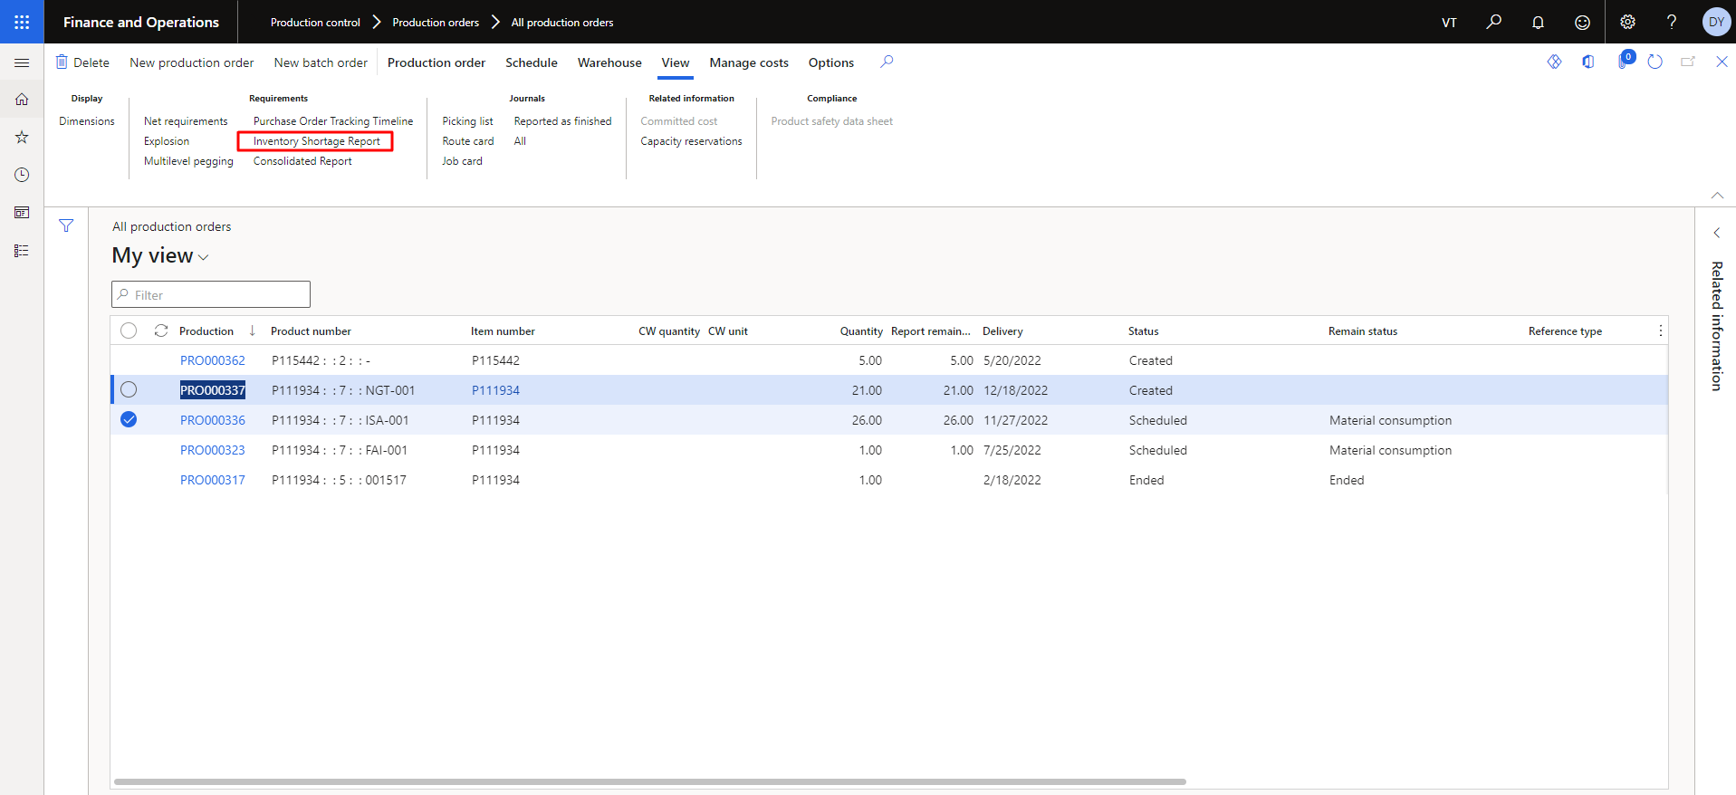

Figure 24 Inventory Shortage Report

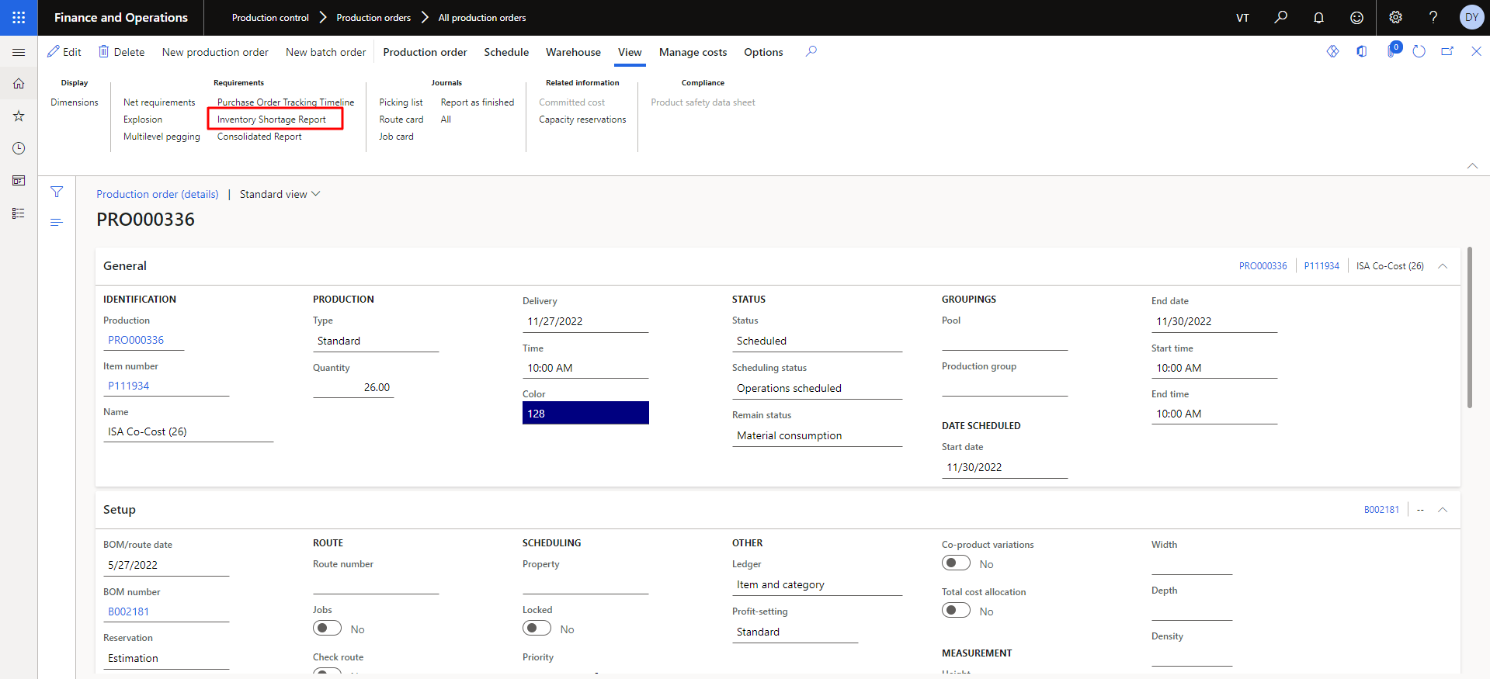

Figure 25 Open Inventory Shortage Report of the production Order

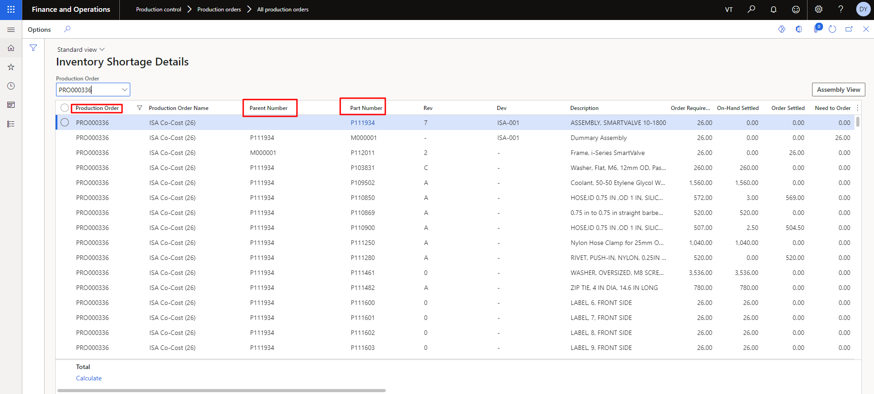

Figure 26 Inventory Shortage Report of the Specific production Order

# Explosion View

This feature gives information regarding bill of materials (BOM). It enhances the view of inventory, available and non-available items. A demand explosion of BOM version generates the demand for each of the BOM line items at specified site and warehouse.

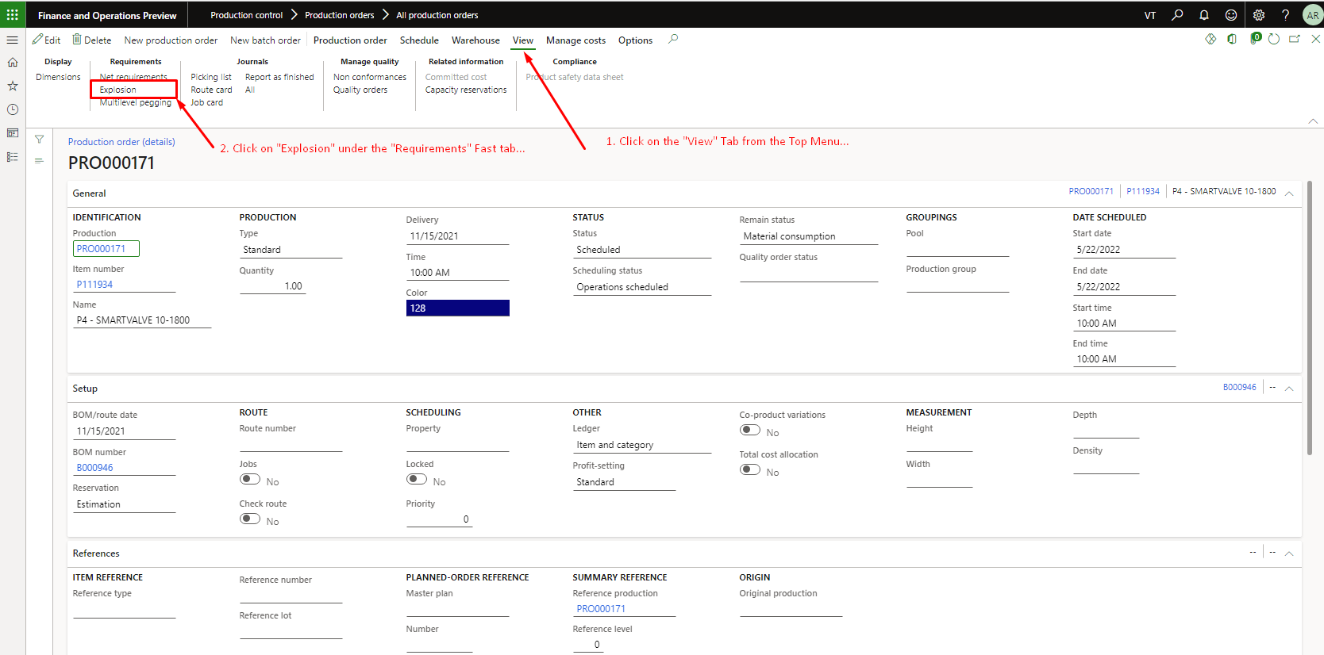

Figure 27 Select the 'View' tab and click on the 'Explosion' Option

## Overview

To get the summary or information about any particular production order, click on the overview option. It will show the list of BOMs, assemblies and sub-assemblies.

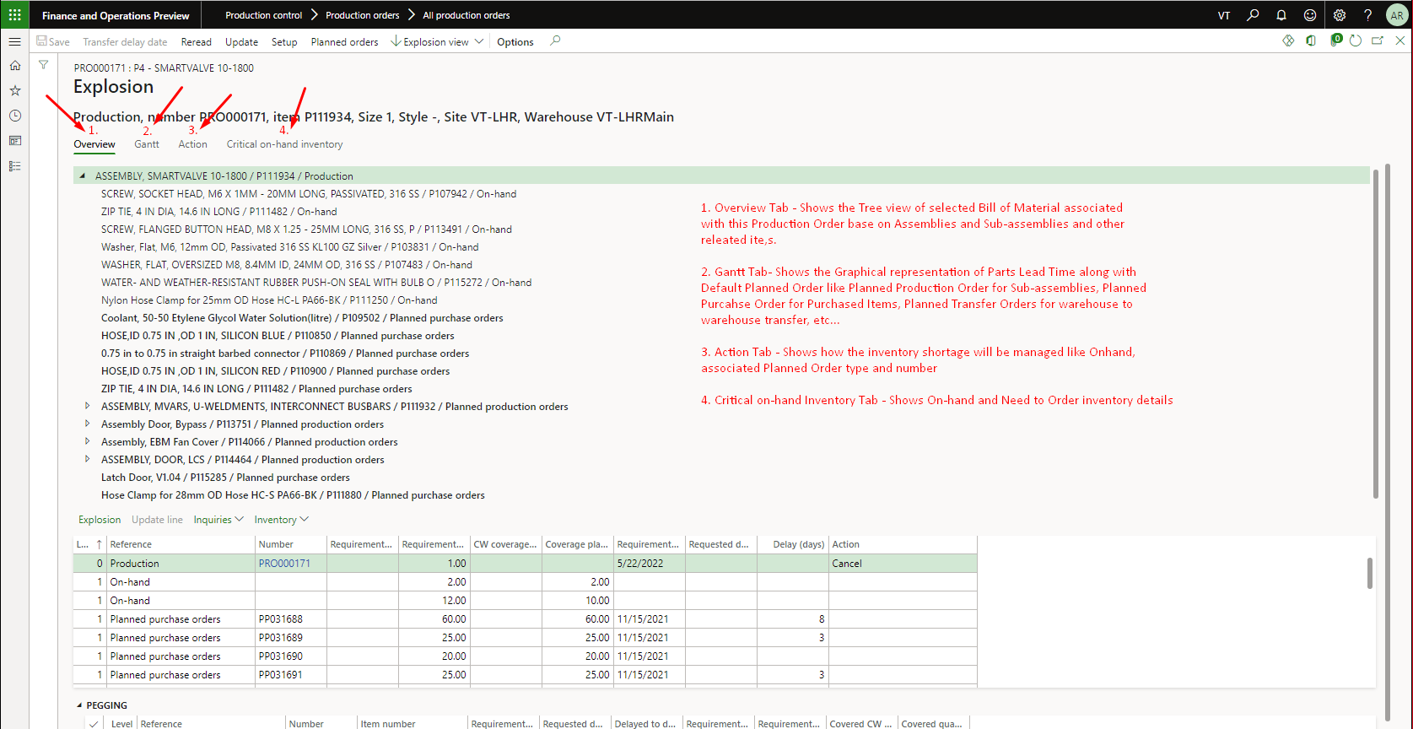

Figure 28 To view BOM’s associated with production order, select the ‘Overview’ Option

## Gantt Chart

It shows the graphical representation of parts lead time. Also, it shows the information about planned production orders for sub-assemblies & purchased items.

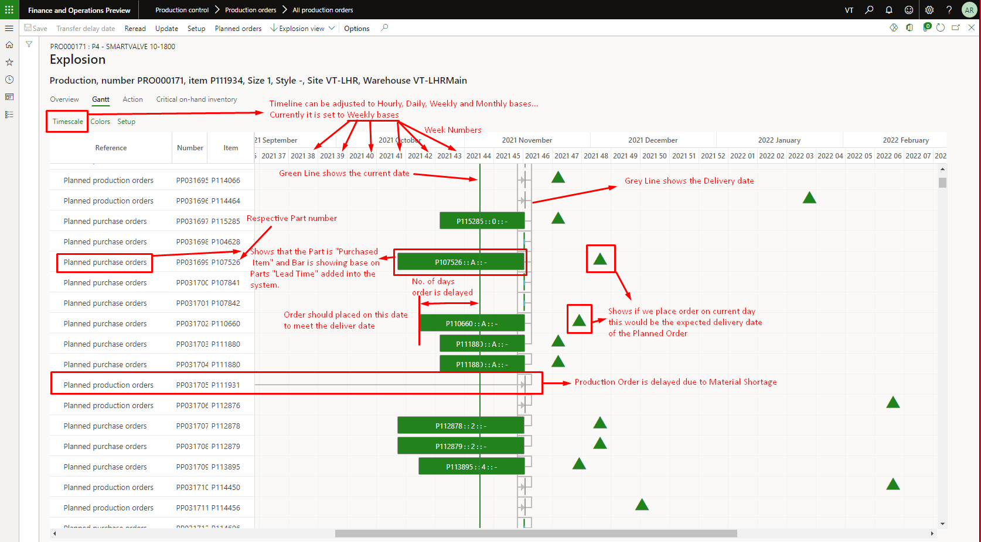

Figure 29 Shows the graphical representation of parts lead time

## Critical on-hand Inventory

It shows the details of inventory items which are on-hand & unavailable items. You can use as a check for items that might have got below the minimum.

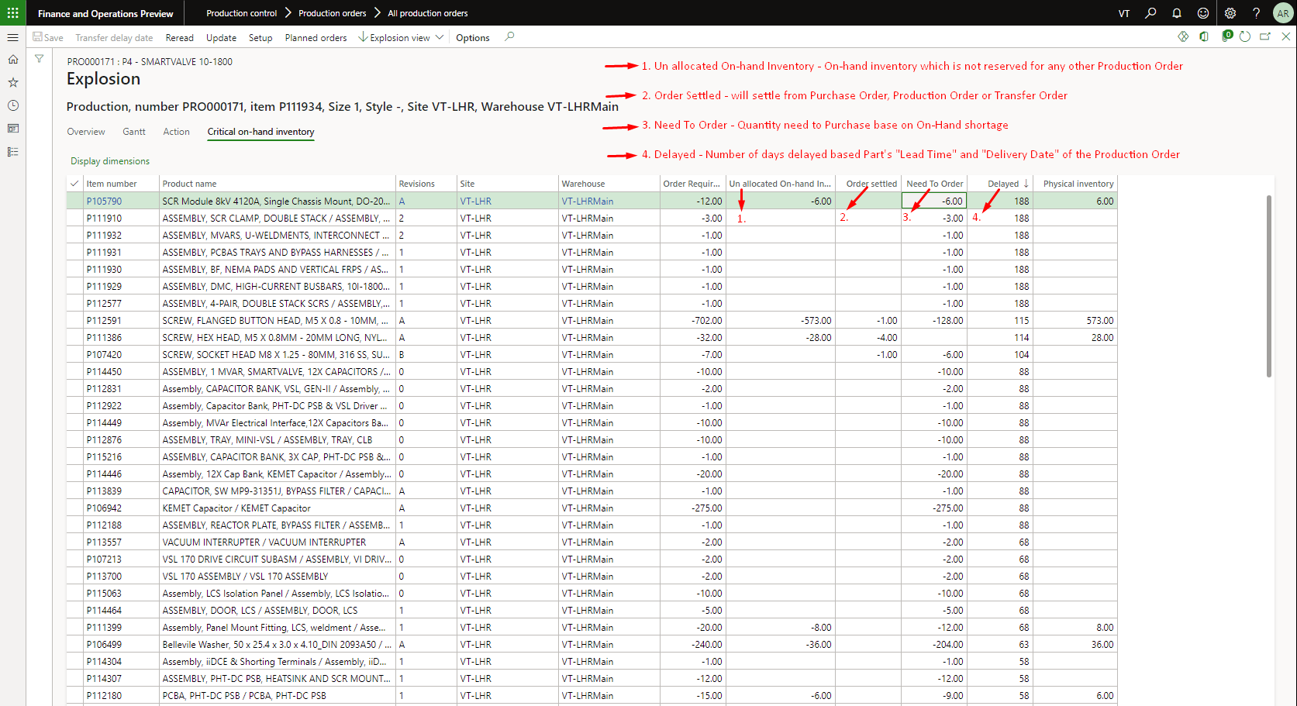

Figure 30 Show on-hand and need to order inventory details

## Action

It will show the information of those items which are on hand or in the process of planned production order. This action tab will help you to filter out inventory shortage items.

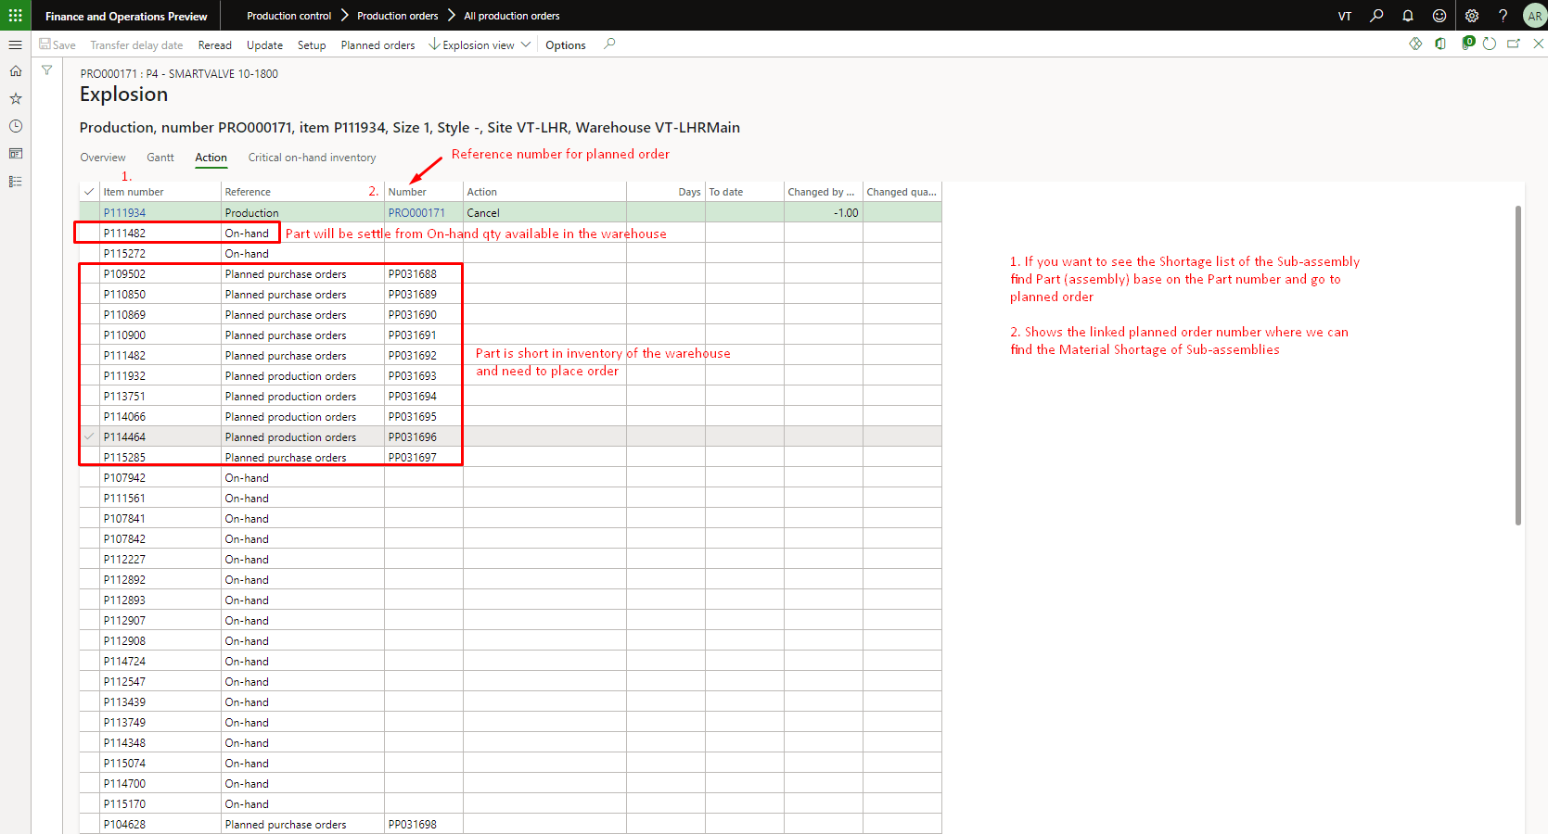

Figure 31 Shows how inventory shortage will be managed

### Filter and Open Sub-Assembly

If you want to know the status of any particular item, click on the filter icon located on the item number column.

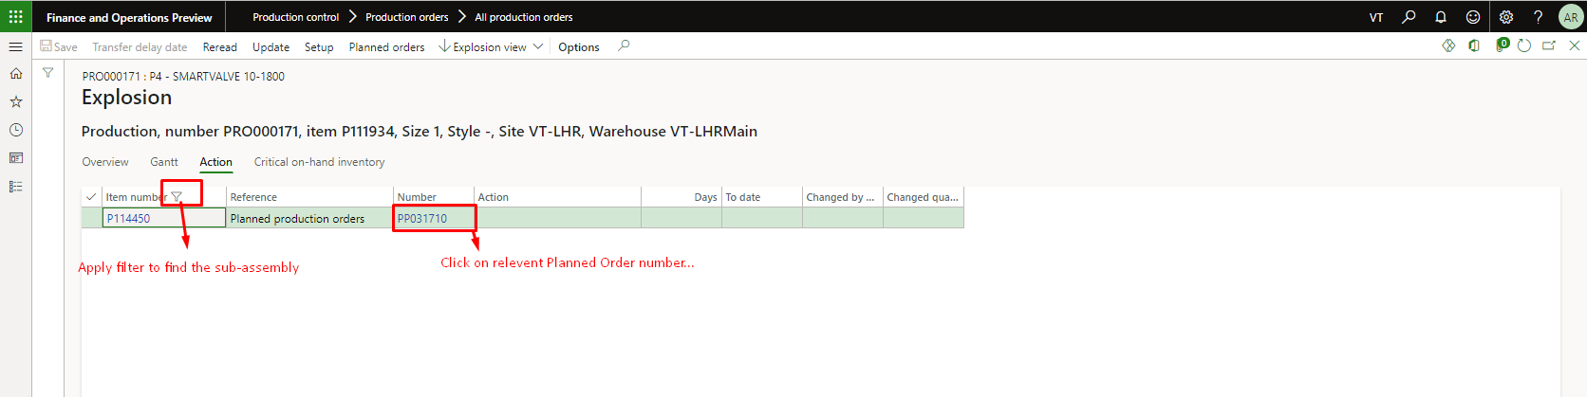

Figure 32 To find specific item number

# Remove Existing Planned Orders

## Explosion View

Explosion view shows the details of production order breakdown like assemblies, sub-assemblies, inventory shortage, on-hand items, Planned production order etc.



Figure 33 Select the 'View' tab and click on 'Explosion'

## Open Planned Orders

Open Planned orders are the type of orders which are not in the confirm stage. To check the planned orders, click on the ‘Planned Order’ option available on the top.

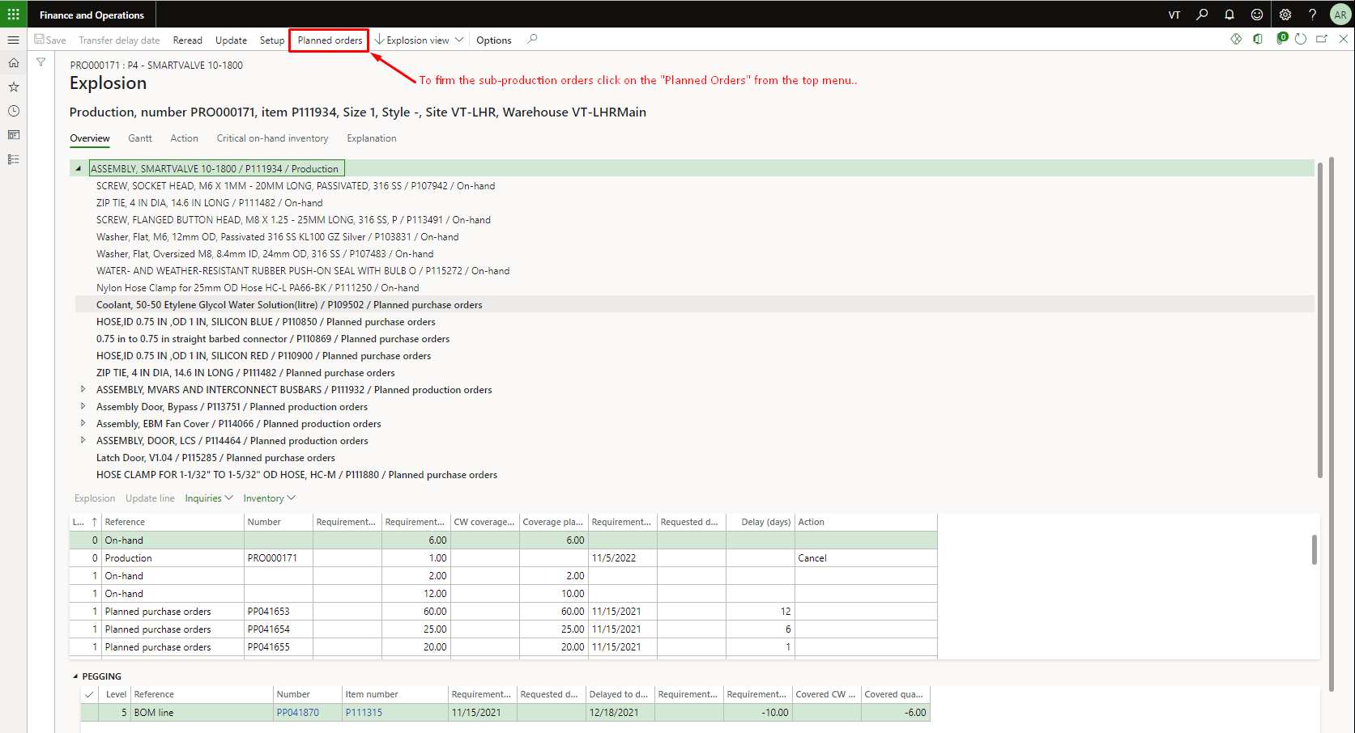

Figure Select the 'Planned Orders' available on top

## Select and Remove Planned Orders

To recalculate production, select all available planned orders and delete them.

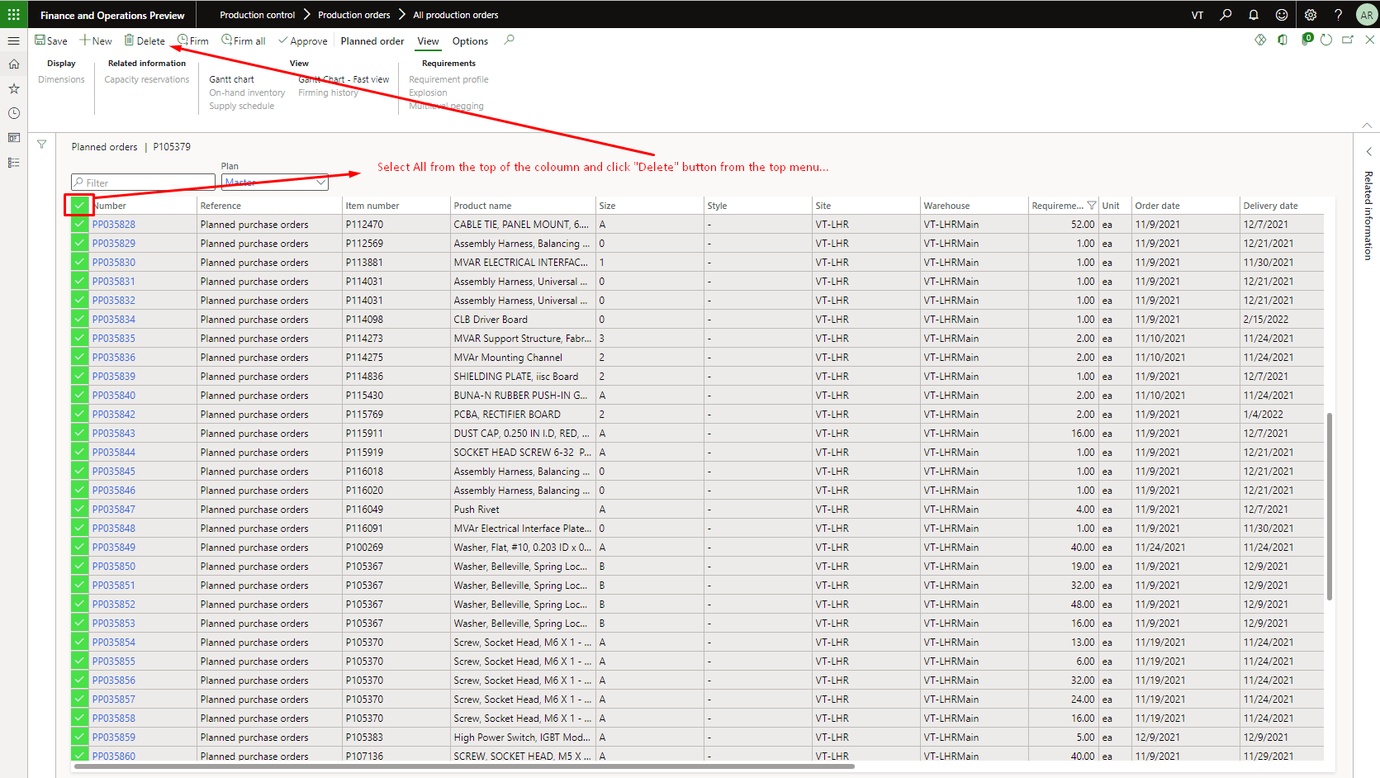

Figure 35 Check mark those planned orders you want to delete

# ****Production Order Calculations (Optional)****

## Recalculate Inventory Shortage Report

**If you want to Recalculate the Inventory Shortage Report of the production order, click on the “Recalculate the Inventory Shortage Report” tab (from purchase order). The user will be able to see the detail pop to calculate the shortage batch job. The need to fill the data as per requirement to calculate job then click on “OK” to submit the calculation. As the user press the “Yes” then user will be able to see the detail pop to fill the data as per requirement to calculate job then click on “OK” to submit the calculation which is also highlighted in the Figure 36 and 37. If another job is in the Queue then user will receive the message to wait until its completed other user will receive the success message. which is also highlighted in the Figure 38 and 39. If the user receives the success message then can check its operation in batch job to check it’s status. Batch job have different status like waiting, error and ending.**

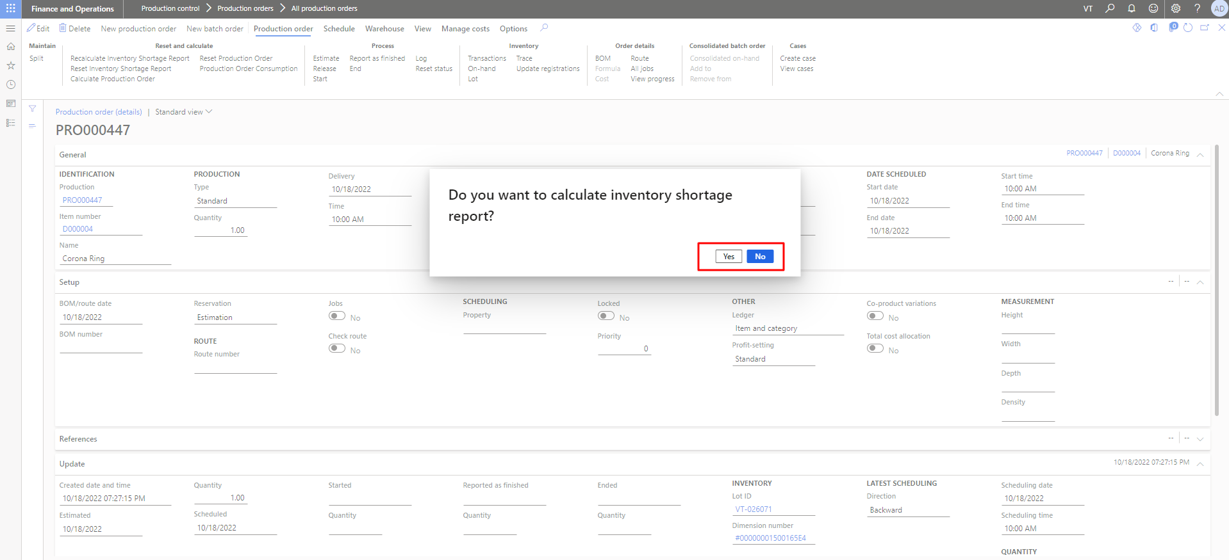

Figure 36 Recalculate Inventory Shortage Report

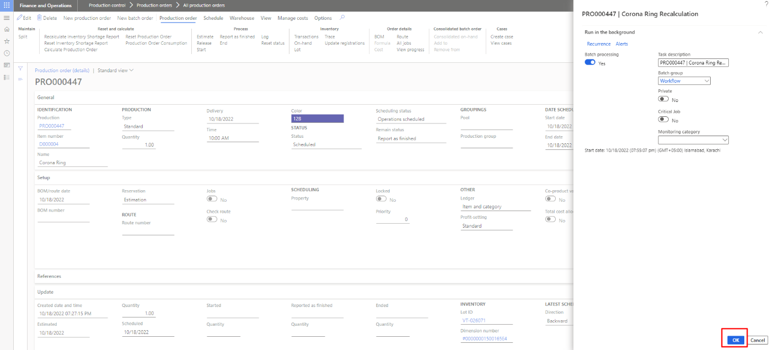

Figure 37 Fill Data and Press OK to Recalculate

The user will receive the access the success message (Job is added in the batch Queue) after performing the recalculations to Inventory Shortage of the production order. It is the automate process to Recalculate the Inventory Shortage Report of the production order.

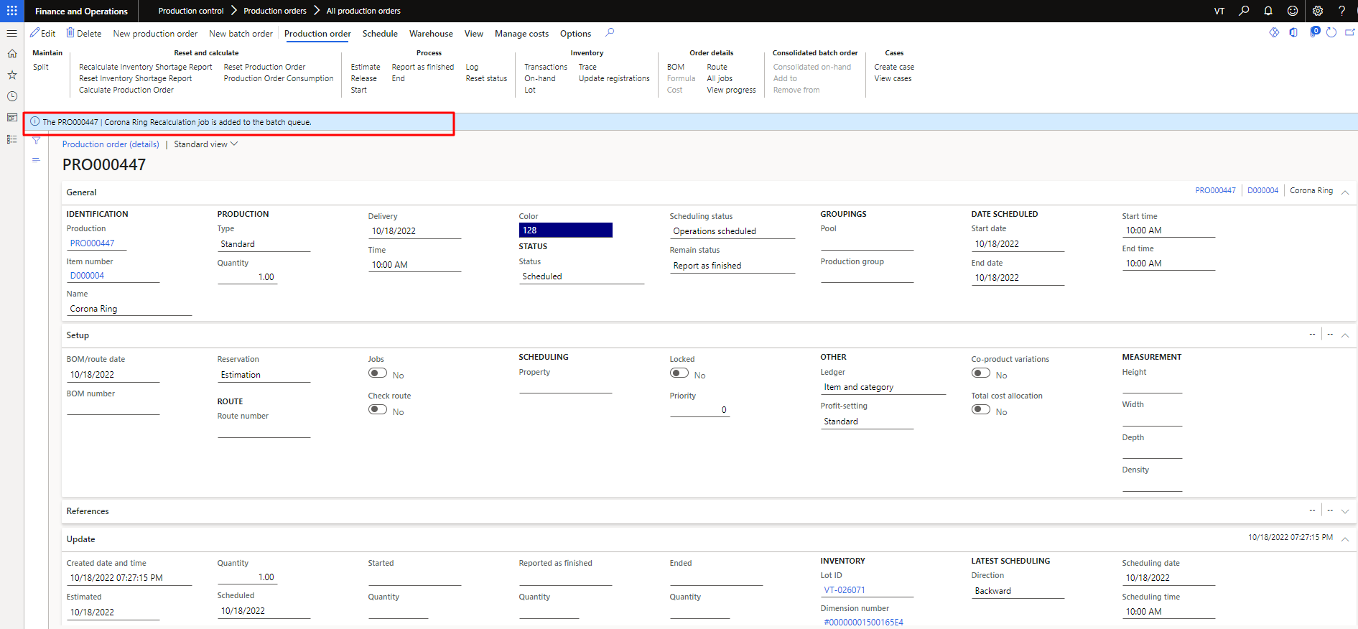

Figure 38 Success Message of Recalculating Inventory Shortage Report

The user will receive the access the Failure message (Please wait for the process to end), If the any of the job is already in the queue.



Figure 39 Wait Message If the already job in Queue

## Reset Inventory Shortage Report

**If you want to Reset the Inventory Shortage Report of the batch job, click on the “Reset Inventory Shortage Report” tab (from purchase order). The user will be able to see the detail pop to calculate the shortage batch job. The need to fill the data as per requirement to calculate job then click on “OK” to submit the calculation. As the user press the “Yes” then user will be able to see the detail pop to fill the data as per requirement to calculate job then click on “OK” to submit the calculation which is also highlighted in the Figure 40. If another job is in the Queue then user will receive the message to wait until its completed other user will receive the success message. which is also highlighted in the Figure 41 and 42. If the user receives the success message then can check its operation in batch job to check its status. Batch job have different status like waiting, error and ending.**

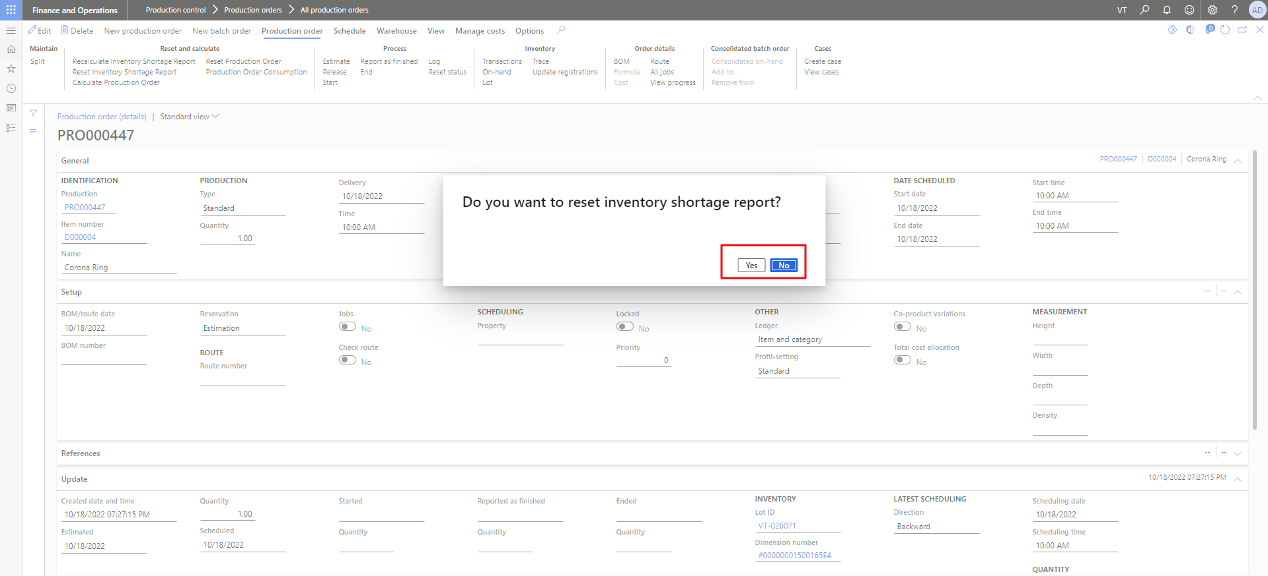

Figure 40 Reset Inventory Shortage Report

The user will receive the access the success message (Inventory Shortage Report has been Successfully reset).

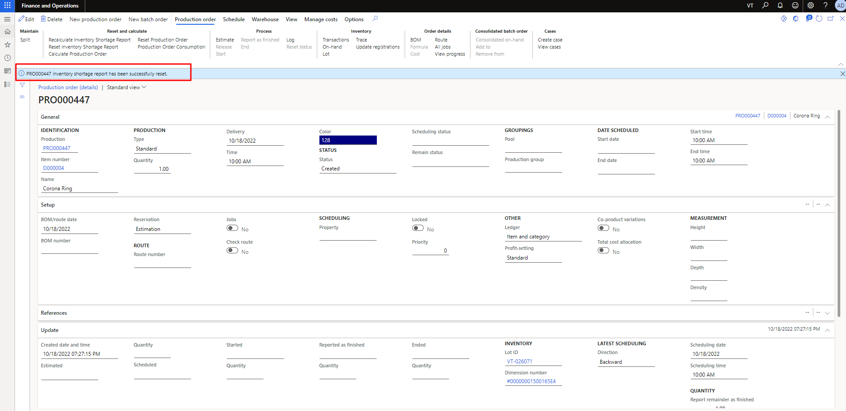

Figure 41 Success Message of Reset Inventory Shortage Report

The user will receive the access the Failure message (Please wait for the process to end), If the any of the job is already in the queue.

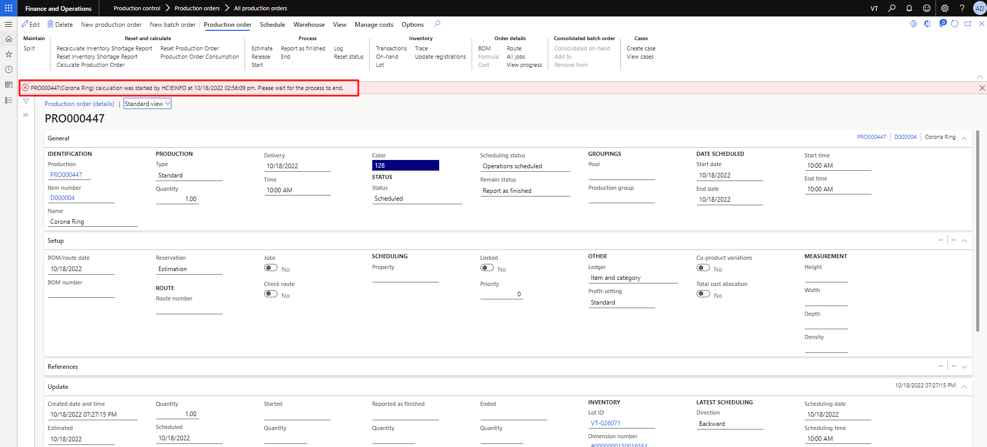

Figure 42 Wait Message If the already job in Queue

## ****Manual Calculation of the production order****

**The user can perform this process in step by step. We have following status/steps “Created”, “Estimated”, “Scheduling”, “Releasing”, “End”. The user has to access the production page to create the production order. The user needs to click on the “Create Production Order” to create any new production order. This process is already highlighted in the Figure 7.**

### Estimation of the production order

In **step 3**, the user needs to go production order then click on “estimate” to calculate the estimation of the item. It will calculate the estimation of the product. As the user will click on it then need to fill update data on the popup form to calculate the estimation. **This process is already highlighted in the Figure 43 and 44.**

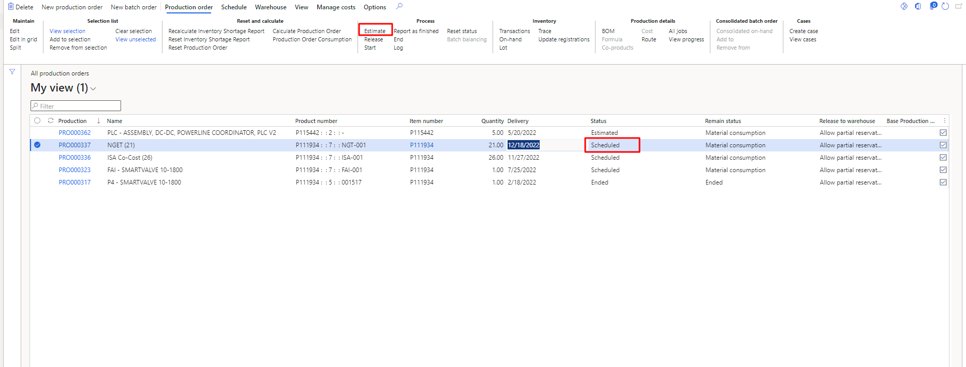

Figure 43 Estimation of the Production Order

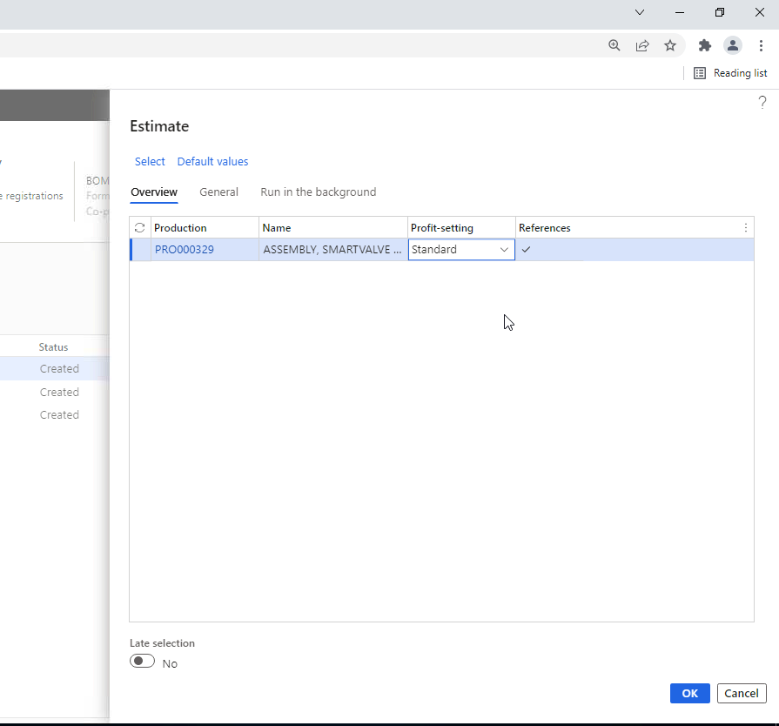

Figure 44 Estimate the values

### Scheduling of the Production Order

In **step 3**, the user needs to go “Schedule” then click on “Schedule Operations” to send the item. It will calculate the estimation of the product. As the user will click on it then need to fill update data on the popup form to calculate the estimation. **This process is already highlighted in the Figure 45,46, 47 and 48.**

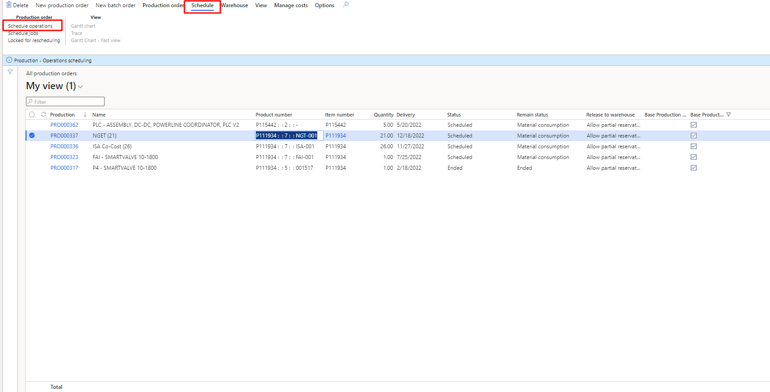

Figure 45 Scheduling of the Production Order

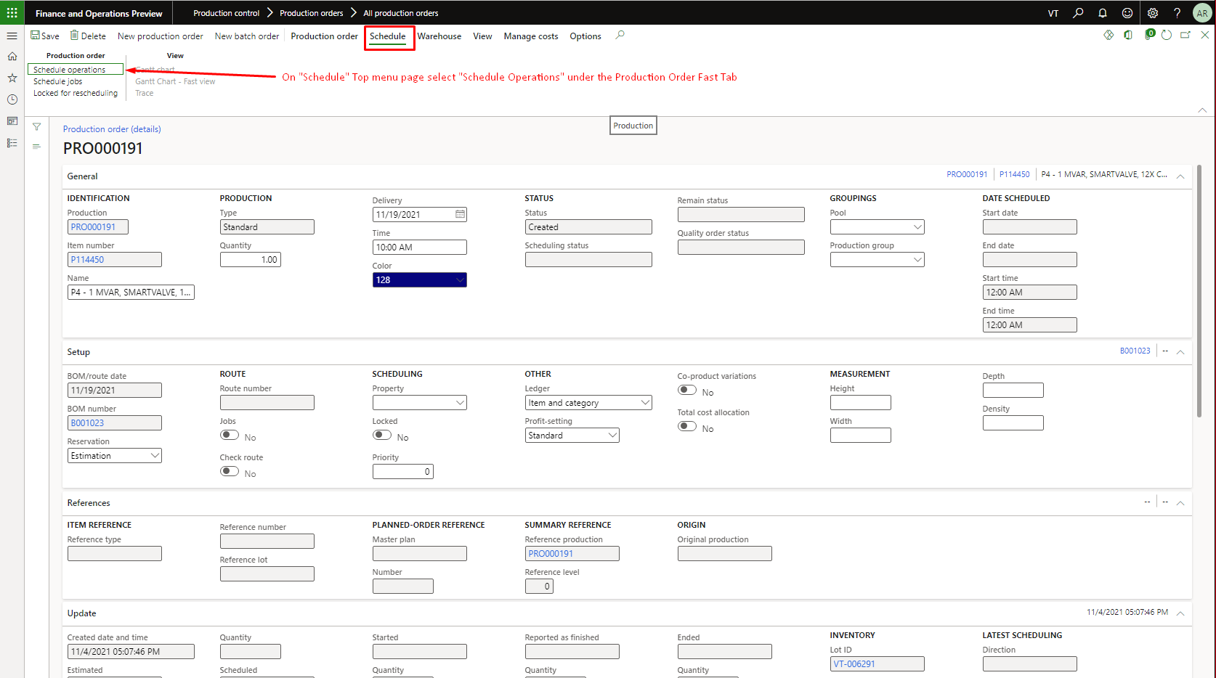

Figure 46 Navigate to 'Schedule' tab and select Schedule Operations

#### Operations Scheduling Parameters

Enter the required parameters for operations scheduling. The direction of scheduling is important to scheduling process.

* Set Scheduling direction to ‘Backward from delivery date’
* Recalculate BOM levels to Yes
* Finite Material to Yes
* Press Ok

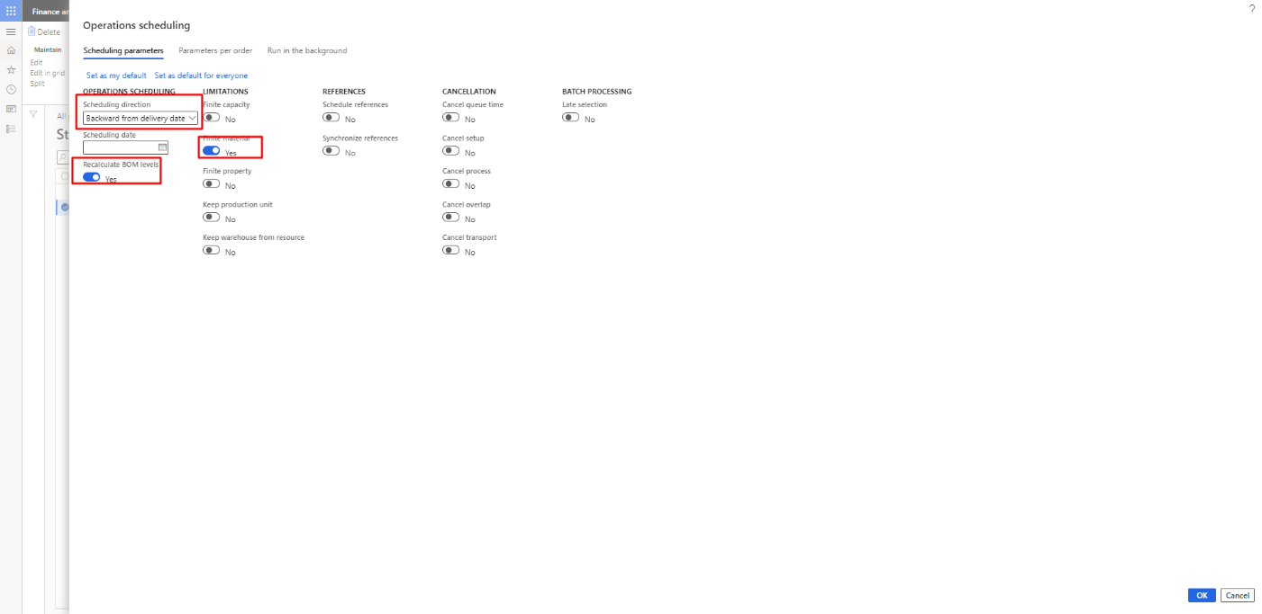

Figure 47 Add parameters in Operations scheduling

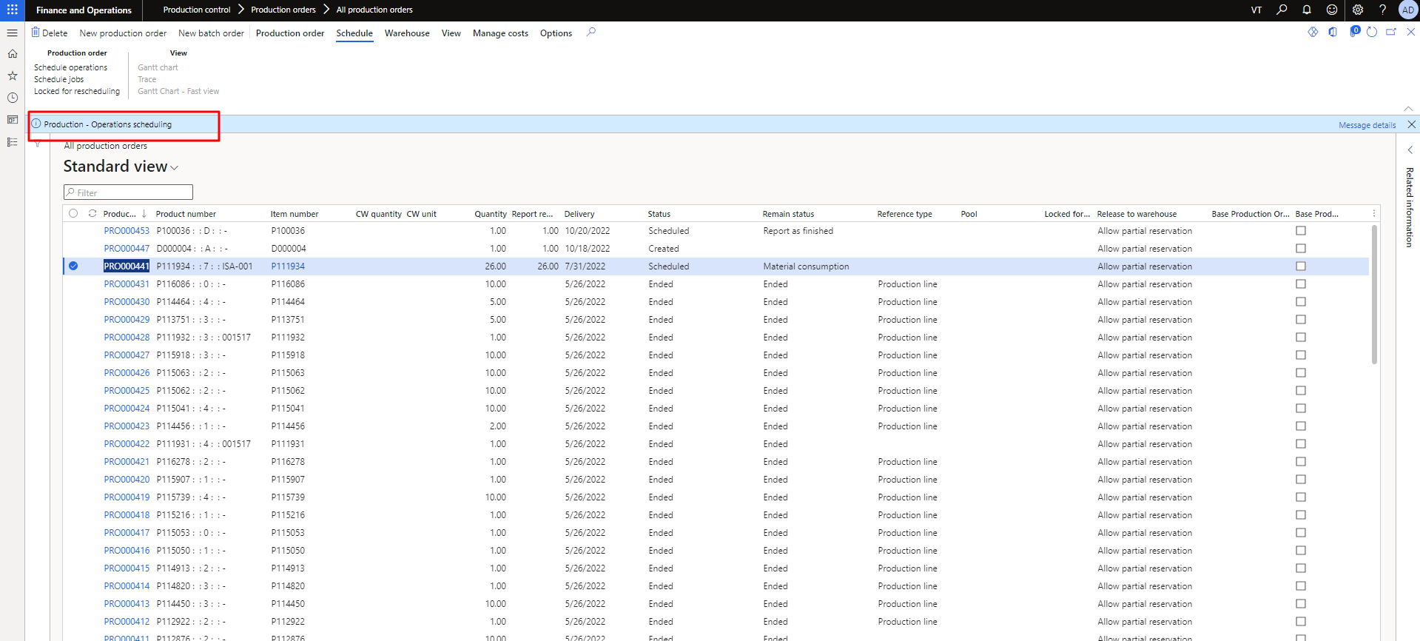

Figure 48 Production Scheduling Completed

### Release of the production order

In **step 4**, the user needs to go production order then click on “release” to forward the item to release. It will forward the item to release. As the user will click on it then need to fill update data on the popup form to calculate the estimation. **This process is already highlighted in the Figure 49 and 50.**

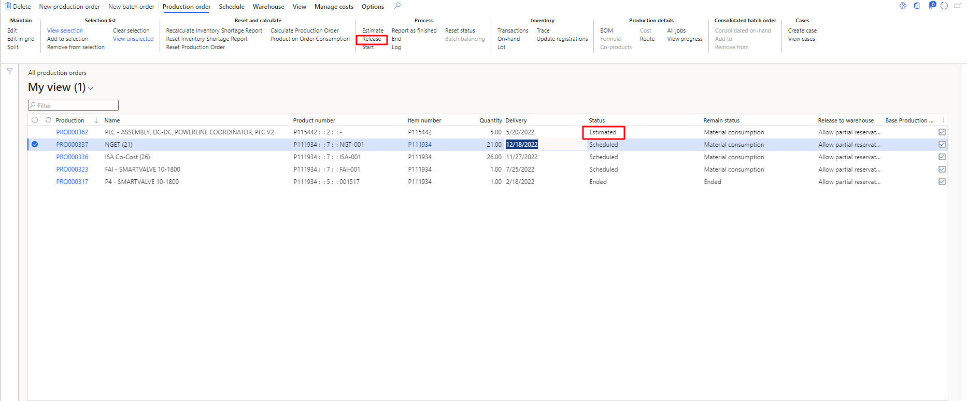

Figure 49 Release of the Production Order

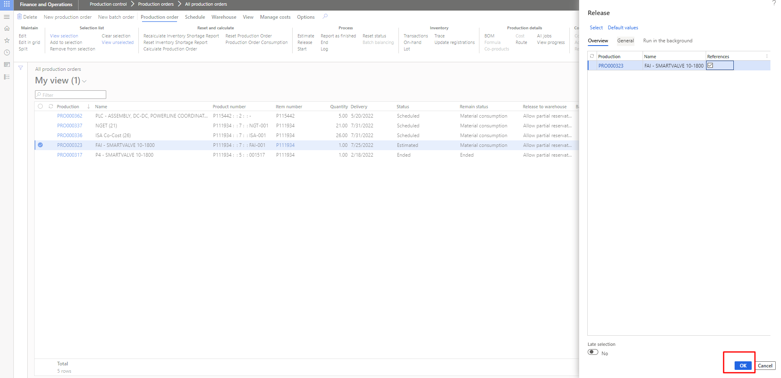

Figure 50 Confirm Data and Press OK

### Reset Status

The user can also reset the status manually. User need to follow the flow (Release, Scheduling, Estimate ) to reset. **This process is already highlighted in the Figure 51 and 52.**

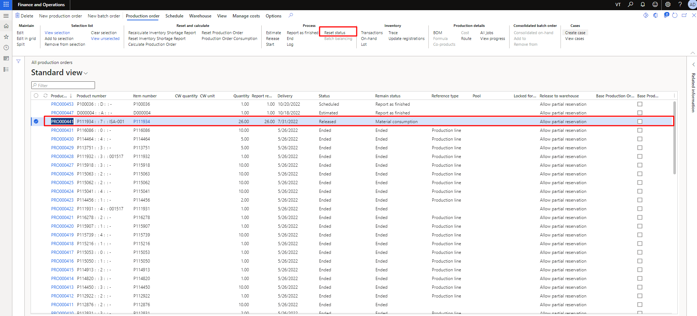

Figure 51 Reset Status

The user needs to select the status to reset. In the below Figure can see status Release to Scheduled id changed.

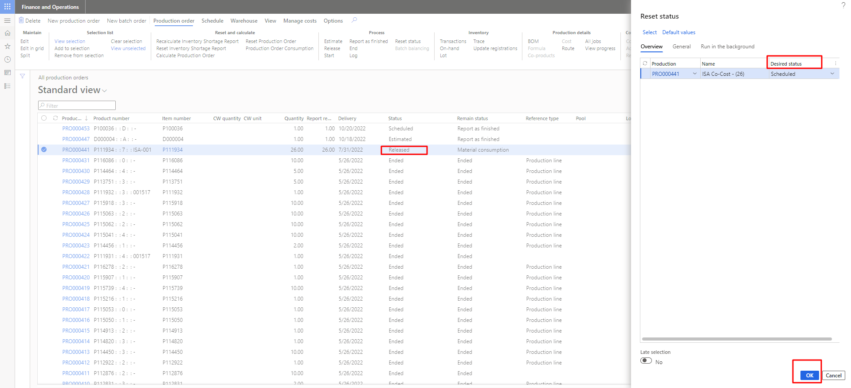

Figure 52 Select Status to Reset Status

### End of the production order

In **step** 5, the user needs to go production order then click on “End” to do the item order end. It will ended the production order. As the user will click on it then need to fill update data on the popup form to calculate the estimation. **This process is already highlighted in the Figure 53, 54 and 55**.

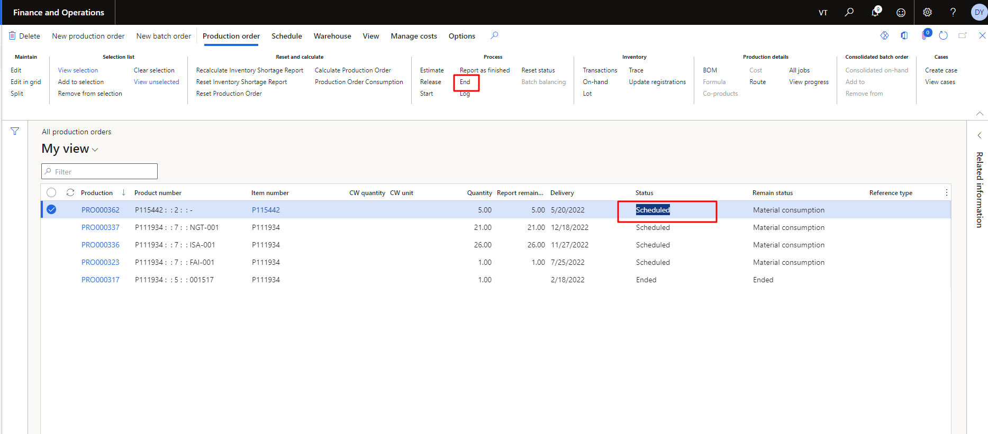

Figure 53 End of the production Order

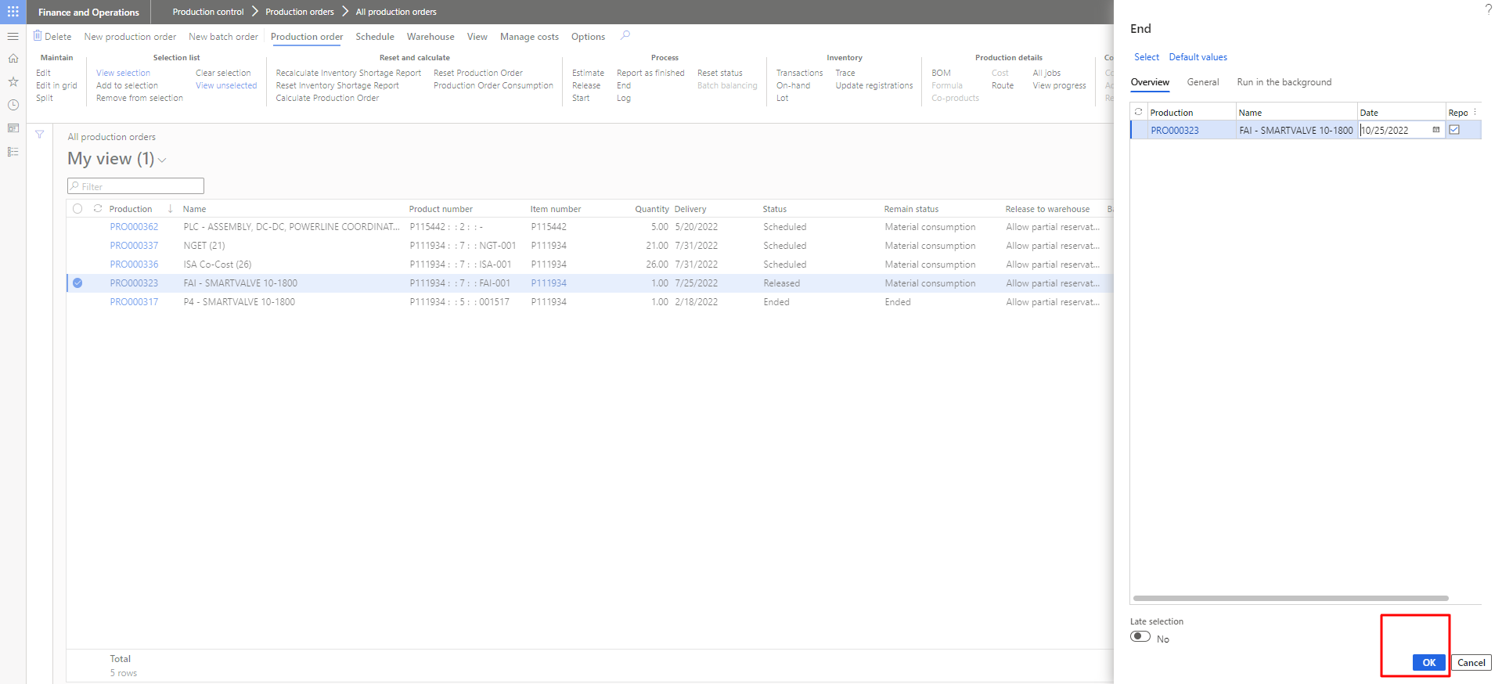

Figure 54 Confirm Data and Press OK

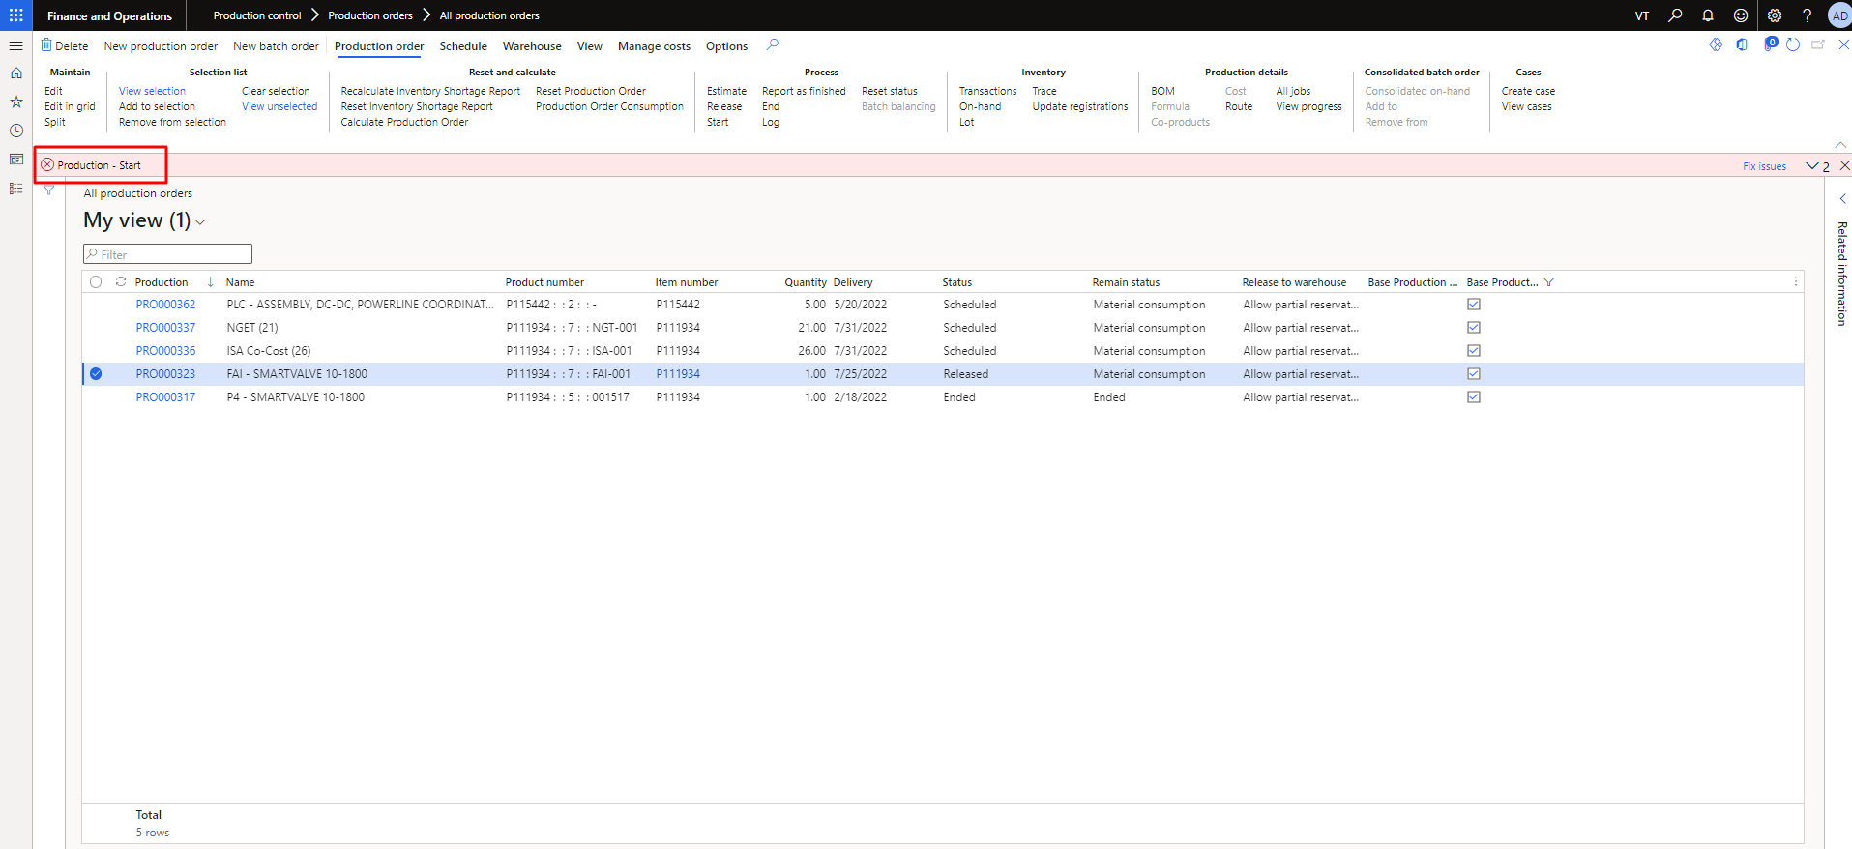

Figure 55 Production Order Ended

# Personalization

## Add columns

### Select Column Header

To personalize the production orders page, select insert columns option.

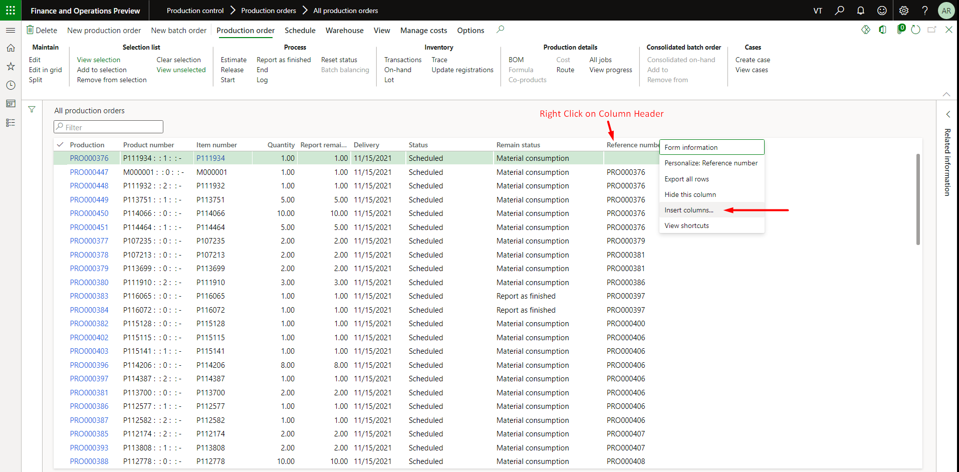

Figure 56 Right click on column header and select 'Insert columns'

### Select Required Columns and Update

Choose the required fields you want to display in the all production orders page.

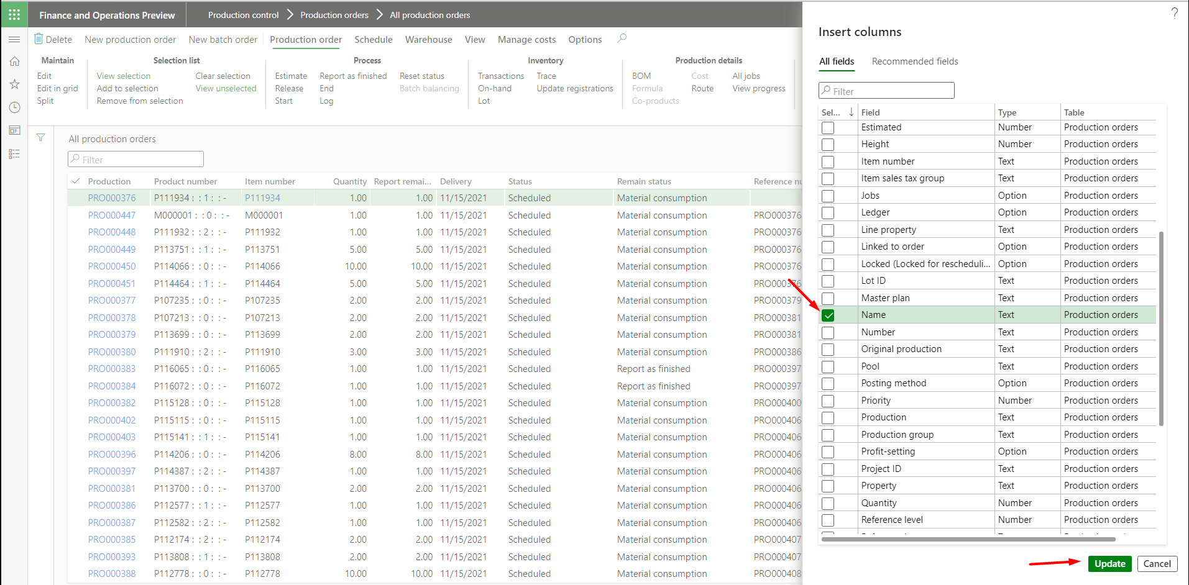

Figure 57 Choose the columns you want to add

## Hide User Control

### Select Control to Hide

There are some of the fields that are hidden in the create new production order panel. Right click on the panel and select Personalize.

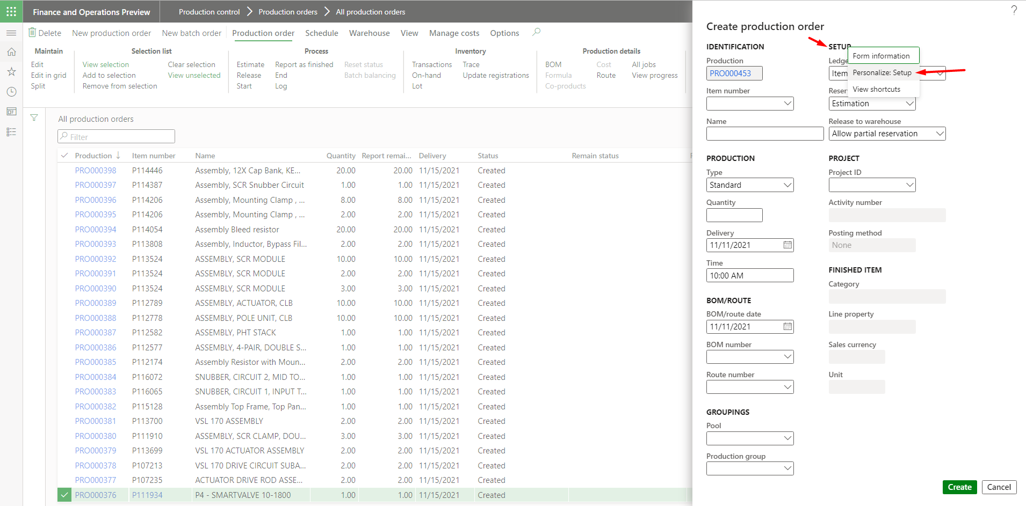

Figure 58 Select the field you want to hide

### Apply Hide Control

Hide the fields, you don’t want to display in the create production order panel.

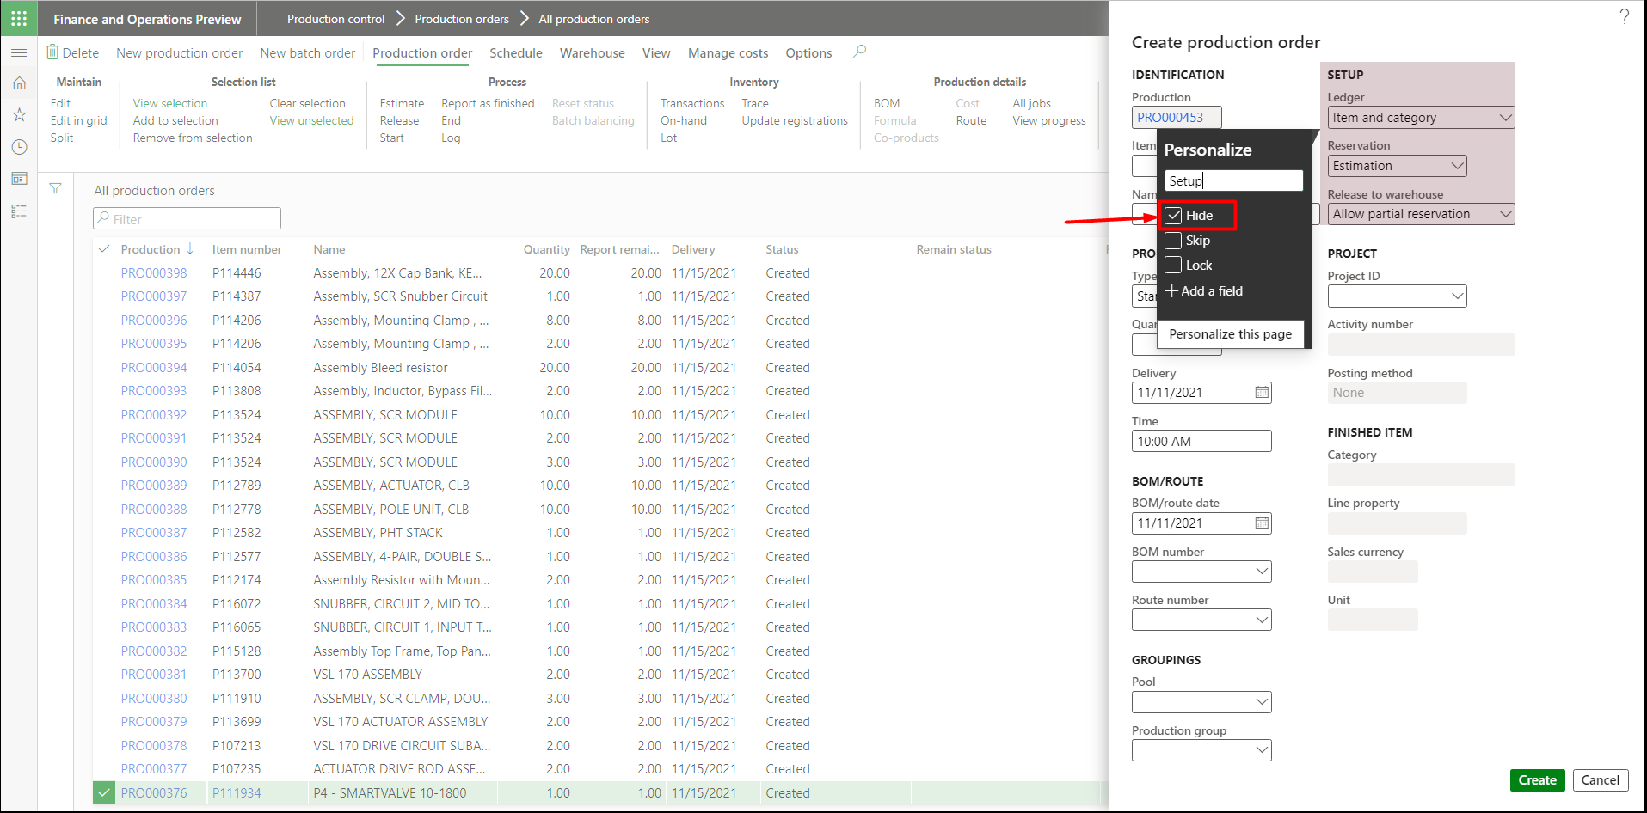

Figure 59 Tick the check box of Hide

## Rename Label

### Personalize Label

If you want to rename any field name, right click on the panel and select the personalize

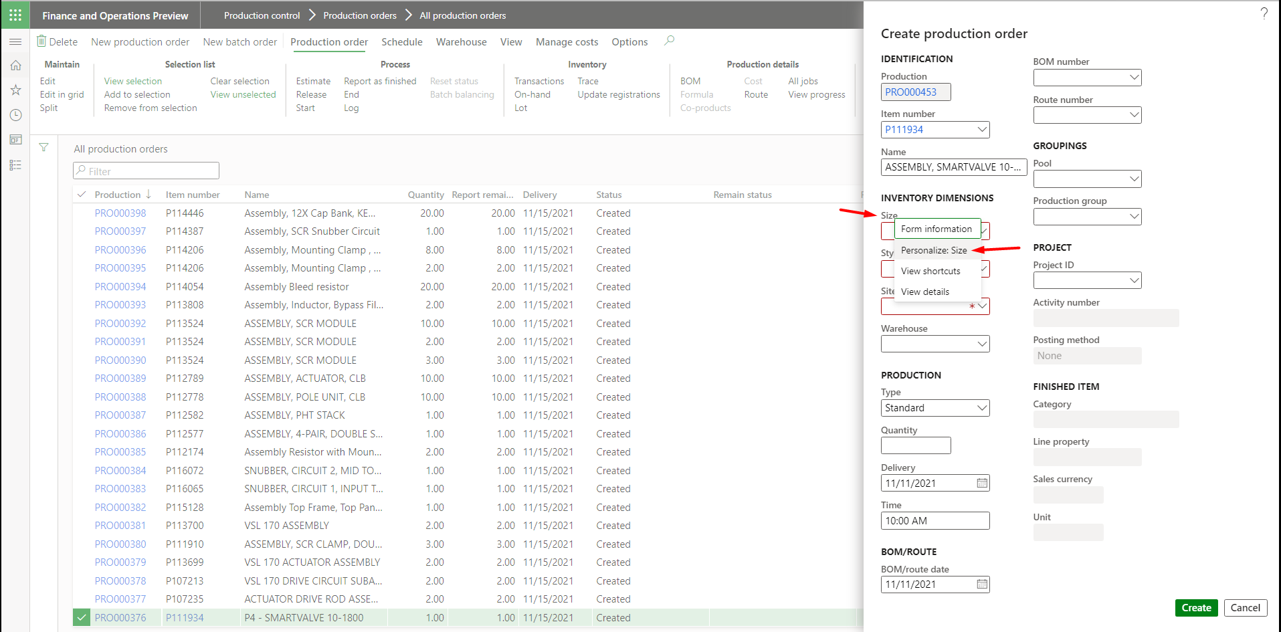

Figure 60 Select the Field You Want to Rename

### Update Label Text

Rename the new field in the personalize box as shown in the figure below.

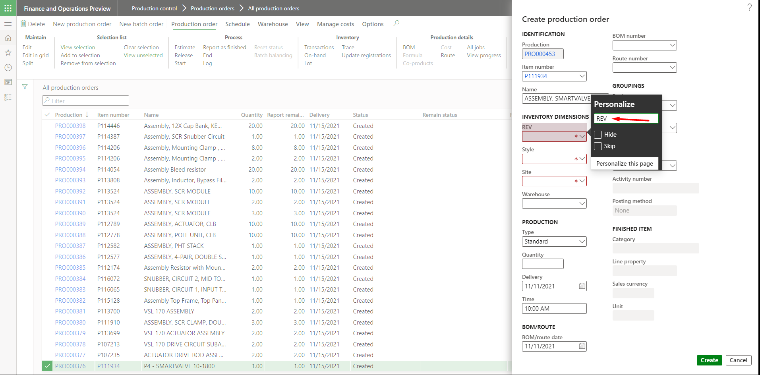

Figure 61 Enter the new field name

## Favorites

### Add to Favorites

Click the star on the option you want to include in ‘Favorites’ category

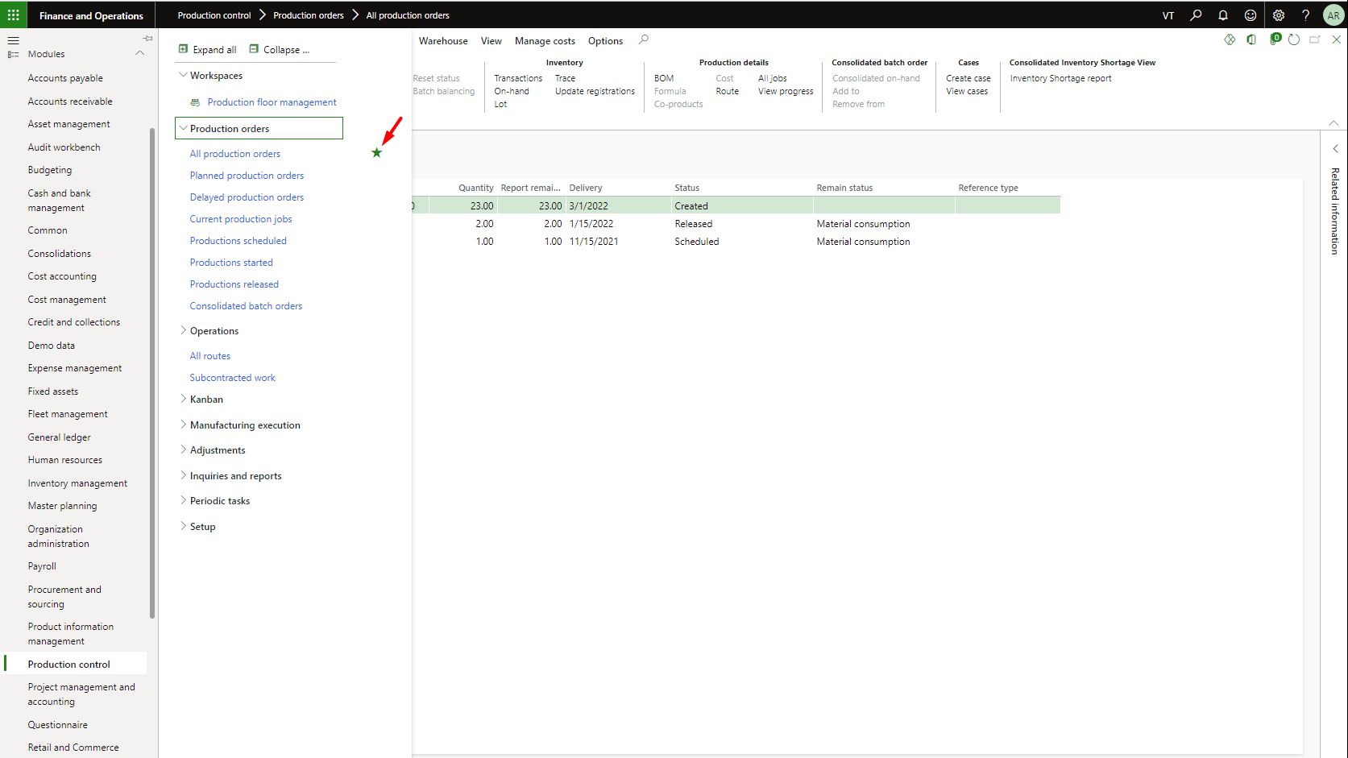

Figure 62 Add to Favorites

### Remove from Favorites

To remove any option from ‘Favorites’ category, click on star from Favorites menu

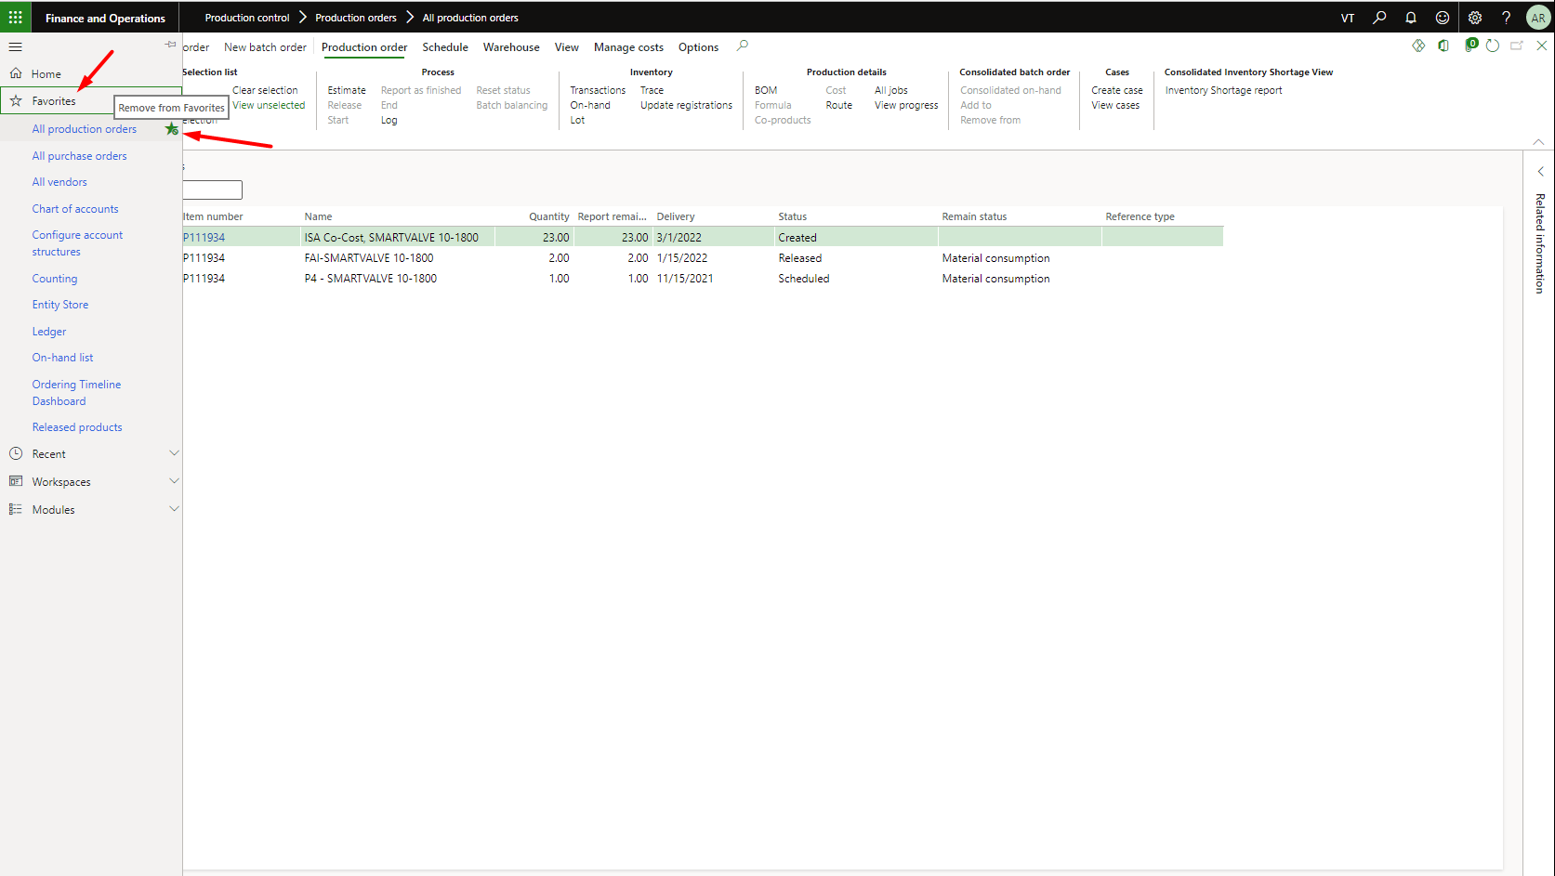

Figure 63 Remove from Favorites